BSIM1001
Professional Experience (PE) 1

Assignment: Portfolio

Name: Chan Yuk Lin, Samantha
Student ID: 2006681569

Programme code: BSc(IM)
HKU Faculty of Education
Due date: 31-7-2007`
Contents

 | Page
Foreword --------------------------------------------------------------------------------------- | 3
- Introduction of Ruttonjee and Tang Shiu Kin Hospitals  - Background Information --------------------------------------------------------  - Mission Statement -----------------------------------------------------------------  - Organization Charts ---------------------------------------------------------------  - Functions of the Dietetics Department ------------------------------------- | 5  6  7  8
- Nature of the Tasks  - Task 1: Apply the “5S” in the workplace -----------------------------------  - Task 2: Dietetic information Centre (DIC) Website Project ----------  2.3 Task 3: Exposure to the existing Information Technology Systems used within the Hospital Authority -------------- | 9  11  13
- Information Models  - Episode 1: Attend the Diabetes Mellitus Education Class  - Description ----------------------------------------------------------------------  - Application of Information Model ----------------------------------------  - Episode 2: Dietetics & Catering Management System (DCMS)  - Description ----------------------------------------------------------------------  - Application of Information Model ----------------------------------------  - Episode 2: Hospital Authority Email Account for Staff  - Description ----------------------------------------------------------------------  - Application of Information Model ---------------------------------------- | 14  16  19  19  24  24
4. Reflection and Sharing of Personal Experience  4.1 Example 1: Re-organization of the Pamphlets and Handouts -------  4.2 Example 2: Evaluation of the DIC Website Project ----------------------  4.3 Example 3: Induction to the Outpatient Services ------------------------  4.4 Example 4: Attend the Food Labeling Class (Basic) --------------------  4.5 Example 5: Observation to the Condemn Board Meeting of Allied Health Division ----------------------------------------------------- | 27  31  33  34  35
Appendix 1: Hospital Background of the Ruttonjee and Tang Shiu Kin Hospitals--------------------------------------------------------------------- | 37
Appendix 2: Scope of Services of the Ruttonjee and Tang Shiu Kin Hospitals ------------------------------------------------------------------- | 39
Appendix 3: Organization Structure of the Hospital Authority -------------- | 41
Appendix 4: Introduction of SMRC model ------------------------------------------ | 42
Appendix 5: Introduction of Shannon – Weaver communication model - | 44
References ------------------------------------------------------------------------------------ | 46

Foreword
No matter in what stage of our career or education, internships can be a valuable experience. We need know what we might learn, where it might lead, and whom we might meet. A good internship is an opportunity that will enrich our education and expose us to skills and duties that we may not have had in the past.
There are many different reasons for participating in an internship. We may want to try something new, expand our knowledge in a particular area and have more working experience. All of these are good reasons for participating in internships.
As for me, the greatest benefit of internship is experience. In the past few years, I have got experience in a variety of libraries including academy library, public library and special libraries. I think it is time for me to try something new and broaden my view in different aspects.
In this summer, I am glad to be offered a summer internship position that was available in the Ruttonjee and Tang Shiu Kin Hospitals. This internship would provide me with the ideal opportunity to familiar with the role of the Dietetics Department within the hospital. Apart from the projects and tasks assisted by the workplace supervisor. I am encouraged to make use of the resources that are available within the hospital such as Staff Library and Health Resource Centre.

Besides, I can further explore how the existing information technology systems such as Dietetic and Catering Management System (DCMS) and Clinical Management System (CMS) used in the hospital can support the daily operation of the DFSD. Such a valuable experience can enable the grounding of the theory of information management to practical situations.

Introduction to My Professional Experience (PE)
Organization:: Ruttonjee and Tang Shiu Kin Hospitals
Workplace Supervisor: Miss Hui Wai Hing, Wendy
Position: Dietitian-in-charge (Dietetic & Food Services Department)
Faculty Supervisor: Dr. Felix SIU
Position: Teaching Consultant
University of Hong Kong,
Faculty of Education,
Division of Information and Technology Studies

Period of PE 1: 13/6/2007 - 13/7/2007
Period of PE 2: 14/7/2007 - 31/8/2007
1. Introduction of Ruttonjee and Tang Shiu Kin Hospitals
1.1 Background Information
The Ruttonjee and Tang Shiu Kin Hospitals (RHTSK) is one of the public hospitals under the Hospital Authority (HA). It is located at the Wan Chai and within the Hong Kong East Cluster (HKEC).
According to the webpage of Ruttonjee Hospital (Ruttonjee Hospital, 2007), the Ruttonjee Hospital (RH) is a “recently - redeveloped hospital with a history that goes back more than 140 years”.
“With more than 600 beds and 1000 staff, Ruttonjee Hospital provides specialist outpatient and hospital services. Its services include medicine, respiratory medicine, surgery and orthopaedic & traumatology as well as comprehensive geriatric care, with a day hospital, a specialist clinic, infirmary beds and community assessment services (See Appendix 2 for the scope of services provided by the hospital). A full range of allied health services are also available.” (See Appendix 1 for the detailed information of hospital background)
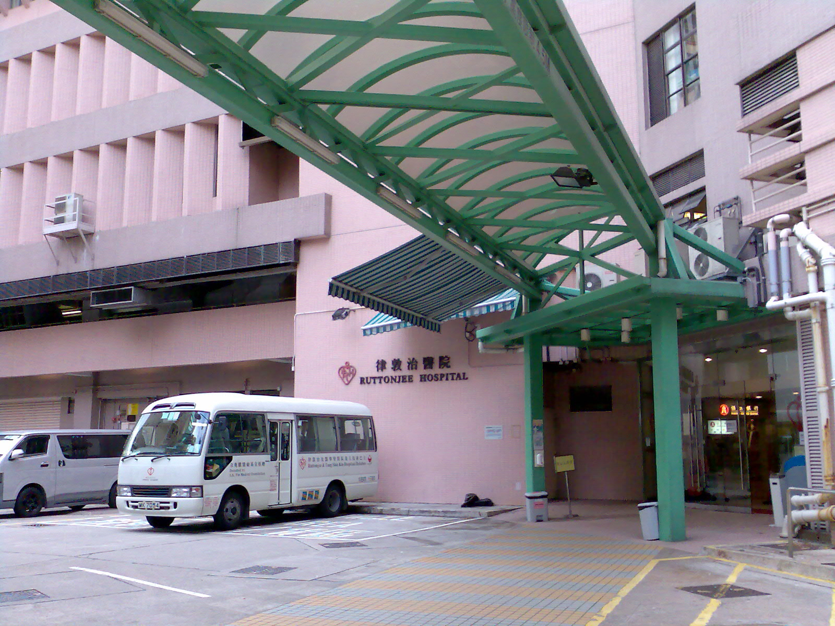 Figure 1: Ruttonjee Hospital
(Source of this photo [Figure 1]: By Chan Yuk Lin, Samantha, on 19 June 2007)
1.2 Mission Statement
The mission of the RHTSK is to “achieve excellence in holistic patient care as a district hospital in partnership with the community” (Ruttonjee Hospital, 2007). In order to achieve the goals, the RHTSK are committed to:
- “building among ourselves highly motivated and well trained multi-disciplinary teams;
- fostering a caring atmosphere throughout the hospital; and
- continuously improving the quality of our healthcare services.”
Besides, the hospital motto is “Whole-hearted Health care for the Whole Person”.

1.3 Organization Charts
In this part, I have drawn 2 organization charts to illustrate the organization structures of (1) Hospital Authority and (2) Hong Kong East Cluster (HKEC).

The graphic software SmartDraw is used for constructing the following organization charts.

Figure 2: Modified organization chart of the Hospital Authority (See Appendix 3)

Figure 3: Modified organization chart of the Hong Kong East Cluster (Hong Kong
East Cluster, 2006)

1.4 Functions of the Dietetics Department
The Dietetics Department is responsible for nutritional screening for patients during cardiac rehabilitation, dietary assessment and therapy for in-patients of the Ruttonjee and Tang Shiu Kin Hospitals (RHTSK) and out-patients from different hospitals of the Hong Kong East Cluster (HKEC).
According to the Triennial Report of the RHTSK (2001 - 2004) and my observation, services provided by the Dietetics Department include the following:
- In-patient Services
- Specialist Out-patient Services
- Diabetes Mellitus Education Class
- Lipid Lowering Class
- Low Fat Low Sugar Cooking Class
- Nutritional Screening Service for the chest ward patients

2. Nature of the Tasks
In this part, I would provide a detailed description of the nature of my work during PE 1.

2.1 Task 1: Apply the "5S" concept in the workplace
Nature and goals of task 1
- To apply the “5S” concept in organization, and re-location of the Dietetic Information Centre and the dietetic stocks

Value of task 1
From perspective of information management within the Dietetics Department, better organization and retrieval of information can be resulted from task 1.
As for information organization, the Dietetics Department can identify the items into 4 categories – Not needed, Rarely used, Occasionally used and Needed. After that, the department can dispose the items according to their categories. It avoids the office storing with more and more unused items.
Regarding to information retrieval, the department staff can identify and retrieve the items easily by arranging the items in a better way.

My role and job duties in task 1
- Orientate to the re-location project of Dietetic stocks in storage rooms, catering office and TSKH.
- Make suggestions on classification of these stocks
- Involve in planning, systematization, sanitation, standardization, and re-distribution of these stocks

2.2 Task 2: Dietetic Information Centre (DIC) Website Project
Nature and goals of task 2
- To update the content of the Dietetic Information Centre (DIC) website (http://www.ha.org.hk/dic) and evaluate the website from a customer view point

Value of task 2
From perspective of information management within the Dietetics Department, task 2 involves website update and evaluation. Since the content is considered to be the most important element of websites (Turban & Gehrke, 2000) and is seen to be directly related to website success (Liu & Arnett, 2000).
According to DeLone & McLean (2003), visitors need to be provided with appropriate, complete and clear information so as to encourage repeat visits.

The 2 major benefits resulted from task 2 are:
- Provide up-to-date nutrition-related information to the public
- Provide a better quality of website by improving the content presentation and navigation of the DIC website

My role and job duties in task 2
- Evaluate the website from a consumer view point and provide an evaluation report
- Prepare website update documents to the website development company – Freedom Communications Ltd
- Provide suggestions for improvement regarding content presentation and navigation of the DIC website

2.3 Task 3: Exposure to the existing Information Technology
Systems used within the Hospital Authority
Nature and goals of task 3
- To learn more about the functions and principles of the information technology systems used within the Hospital Authority

Value of task 3
Task 3 provides the opportunity for me to familiar with the existing information technology systems that support the daily operation of the Dietetics Department.

My role and job duties in task 3
- Read the relevant documents (e.g. user guide) about the information technology systems
- Observe the role of the various personnel in using the IT systems

3. Information Models
There are a range of models relating to information management. In the part, I would describe the application of information process models I have previously learned during the BSc(IM) to 3 actual situations in my workplace.

3.1 Episode 1: Attend the Diabetes Mellitus (DM) Education
Class
In the following part, I would use 2 models to apply on this episode. They are SMCR Model and Shannon – Weaver communication model. The strength of the SMCR Model lies with the manner in which it represents the complexity of communication and treats communication as a process. The limitations are lack of feedback and not illustrating the process function.
However, the application of Shannon – Weaver communication model implies that the communication between the facilitators and the audiences should not be one way.

Description
Event: Diabetes Mellitus Education Class
Venue: Seminar Room 5, 5/F, Block C, Ruttonjee Hospital
Date: 25 June 2007
Time: 9:00am – 4:30pm
Target Audience: Diabetes and their relatives

The objective of this DM Education Class is to offer instructions in the following topics:
 | Time | Topic | Facilitator
Lesson 1 | 09:15 – 10:30 | What is Diabetes? Diabetes Complications | Nurse Specialist (Diabetes Care)
Lesson 2 | 10:30 – 11:30 | Foot Care | Podiatrist
Lesson 3 | 11:30 – 12:30 | Healthy Eating | Dietitian
 | 12:30 – 13:30 | Lunch Time | Dietitian
Lesson 4 | 13:30 – 14:45 | Diabetes and You | Doctor
Lesson 5 | 14:45 – 15:30 | Diabetes – Lifestyle | Nurse Specialist (Diabetes Care)
Lesson 6 | 15:30 – 16:30 | Exercise and Diabetes | Physiotherapist
Lesson 7 | 16:30 – 16:45 | Questions & Answer | Nurse
Figure 4: Schedule of the Diabetes Mellitus Education Class
Source:
Ruttonjee & Tang Shiu Kin Hospitals, “Introduction of Diabetes Mellitus Education Class”, Plamplet, 2007.

Application of Information Models
SMRC model
The SMRC model can demonstrate the communication pathway in episode 1 (See Appendix 4 for the introduction of SMRC model).
Facilitators | → | Diabetes  Instructions | → | Face-to-Face | → | Audiences
(source) |  | (message) |  | (channel) |  | (receiver)
Figure 5: Application of SMRC model for Episode 1

This linear model can illustrate the communication process between the facilitators and audiences. For example, the nurse specialist talk about “What is Diabetes?” and “Diabetes Complications” in lesson 1 (See Figure 4).
As you can see, the model represents a communication process that occurs as a source deliver messages based on one’s communication skills.
These messages are transmitted along channels. A receiver interprets them based on the individual’s communication skills.
- The facilitators act as the sources that start the communication.
- The message (Diabetes Instructions) is what the sources (facilitators) want the receivers (audiences) to know.
- The face-to-face is the major form of channel that the message is transmitted.
- The receivers are the other end of the communication.

Shannon – Weaver communication model
In the following part, I would like to talk about how the Shannon – Weaver communication model can apply to the episode 1 (See Appendix 5 for the introduction of Shannon – Weaver communication model).
 |  | (feedback)
Facilitators | → | Language | → | Face-to-Face | → | Ears | → | Audiences
(source) |  | (transmitter) |  | (channel) |  | (receiver) |  | (destination)
 |  |  |  | (noise)
Figure 6: Application of Shannon – Weaver communication model for Episode 1
- The facilitators are regarded as the sources for delivering information.
- Language is the transmitter and the communication channel is face-to-face.
- The ears are act as the receivers and audiences are the destination of this communication.
- Noise is audiences’ own knowledge, attitudes, or beliefs. Therefore, each audience may have his / her own interpretation on the information he / she received.
- Feedback refers to audiences’ opinions that concern the education class.

Information Problems:
- As for the audiences (diabetes and their relatives), it may be too harsh for them to have such a long period of lesson. I think that it is not easy for them to concentrate such a long period of time. Thus, the information received by the audiences may not be as well as the facilitator expected.

Reflection of Episode 1
I think it is a great idea for me to know more about how the diabetes receives information from different diabetes care providers (e.g. nurse, doctor, dietitian, etc.) I am not only an information receiver but also an observer. I found that the Education Class can provide evidence – based knowledge of self-management in diabetes and enhance communication between medical staff and patients.

3.2 Episode 2: Dietetics and Catering Management System (DCMS)
Description
I am assisted to familiar with the Dietetics and Catering Management System (DCMS營養及膳食管理系統). DCMS is developed to achieve savings in food production and improvements in the therapeutic diet orders and patient records. It is an important management system for the Dietetics Department, the Catering Department and the ward.
By using information technology, the hospital Authority can deliver more direct benefits to the patient and the staff.

Application of Information Model
Information transfer model
Use – DCMS is developed to achieve savings in food production and improvements in the therapeutic diet orders and patient records.

Create – The creation of DCMS is a product of the collaborative efforts of the team to develop a management system.

Collect – The information of therapeutic diet orders and patient records is recorded in electronic format for collection. The information is kept confidential and has restricted access.

Organize – The DCMS is mainly divided into 6 parts: Diet Order Entry, Menu Planning, Nutrition Analysis, Trading System, Inventory Control and Table Maintenance. The information is organized into different parts of them.

Store – Theoretically, the information in DCMS for each patient is stored once they are admitted in the hospital. Even the patients are discharged; their information in the ILN will not be removed.

Access – there are 5 groups of users have the right to access the information inside the DCMS. They are Nurses, Catering Colleagues, Dietitians, Security officers and Administrators. The hospital staff must have the right in order to utilize functions offered by the system.
Once a hospital staff has received a login account and the corresponding password, he / she can log into the system (See Figure 7) via the DCMS terminals.
According to the Dietetics & Catering Management System Diet Order Entry Module - User Guide (2003), a user account table contains the authenticated user information. It implies a set of grant rights, so that user can only do what he / she supposed or authorized to do.

Deliver – Users can access and update the information after they have logged in the DCMS.
For example, users can select the “Diet Order Entry” from the Main Menu. They will see the screen of Patient List, similar to Figure 8. The users will see the “Diet Order Entry” screen when they have click the “Diet Order Entry” link from the “Patient List”.
This screen is separated into 2 frames - the upper frame and the lower frame. The upper frame contains the patient’s personal information and the lower frame contains the patient’s diet information.
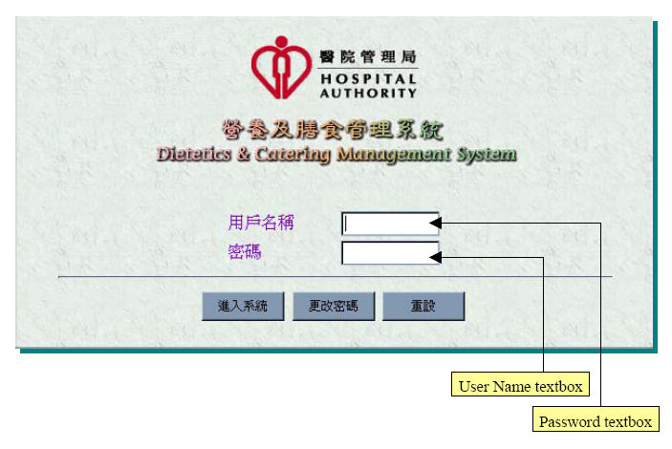
Figure 7: DCMS Logon screen
Source:
Hospital Authority [Hong Kong]. (2003). Dietetics & Catering Management System Diet Order
Entry Module - User Guide Hong Kong: Hospital Authority, p. 2.

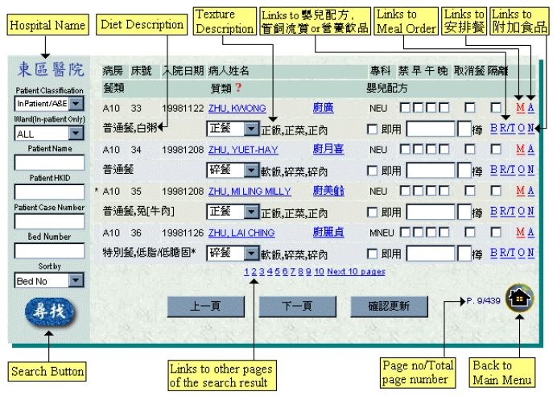
Figure 8: Patient List screen
Source:
Hospital Authority [Hong Kong]. (2003). Dietetics & Catering Management System Diet Order Entry Module - User Guide Hong Kong: Hospital Authority, p. 4.

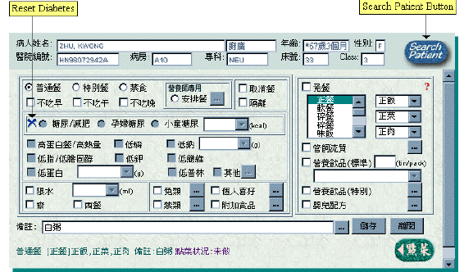
Figure 9: Diet Order Entry screen
Source:
Hospital Authority [Hong Kong]. (2003). Dietetics & Catering Management System Diet Order
Entry Module - User Guide Hong Kong: Hospital Authority, p. 5.
3.3 Episode 3: Hospital Authority Email Account for Staff
Description
Most of the announcements and important notices from the different departments of the hospitals and the Hospital Authority will be received via the Hospital Authority email account.
Therefore, the staff should check the emails regularly to ensure that they are kept informed of latest notices.

Application of the information models
SMCR model
This model can simply demonstrate the communication pathway with different group of people within the hospitals.

Hospital Authority | → | Email | → | Internet  (Hospital Authority email account) | → | Staffs
(source) |  | (message) |  | (channel) |  | (receivers)
Figure 10: Application of SMRC model for Episode 3
- The different departments of the hospitals and the Hospital Authority act as the sources that start the communication.
- The messages (emails) are what the sources want the receivers to know.

- The Internet (Hospital Authority email account) is the medium through which the messages (emails) are transmitted. It is a form of controlled media.
- Staffs are the receivers in this communication model. They may be actively seeking to receive the messages (emails) or may be surprised by them. They may be the intended target or just someone who is within receiving range. They will decode the messages and create their own meaning.

Shannon – Weaver communication model
In this model, communication is represented as a system in which a source selects information that is formulated into a message.
The following part will be used to illustrate how the Shannon – Weaver communication model can apply to the information transfer process through the Hospital Authority email account.

 |  | (feedback)
Hospital Chief Executive (HCE) of RHTSK* | → | HCE’s email account | → | Internet | → | staffs’ email account | → | Staffs
(source) |  | (transmitter) |  | (channel) |  | (receiver) |  | (destination)
 |  |  |  | (noise)
Figure 11: Application of Shannon – Weaver communication model for Episode 3
* Remark: RHTSK – Ruttonjee and Tang Shiu Kin Hospitals
- Hospital chief Executive (HCE) of RHTSK is regarded as a source for sending mass email to its staffs.
- For example, Dr MA Hok Cheung (the Hospital Chief Executive of RHTSK) sent out the message (email) about the new announcement about infectious control within the hospital from the his email account (transmitter).
- Staffs’ email account received this email through the Internet.
- Staffs act as the destination of this communication process.
- If the staffs have any question related to this issue, they can reply an email to Dr. Ma via their Hospital Authority email account. It is a kind of feedback.
Reflection and Sharing of Personal Experience
In this part, I would share my personal experience learnt from PE 1. It covered both task based activities and other organizational observations.

4.1 Example 1: Re-organization of the Pamphlets and Handouts
Re-organization of the pamphlets and handouts is one of the subtasks in task 1. My job duties of this subtask are listed as follows:
- Understand the filing system of the pamphlets and handouts
- Find out the out-dated pamphlets and handouts and then withdraw them
- Prepare a new classification name list for the pamphlets and handouts
- Revise the new classification name list with Miss Hui
- Print out the new classification name list for filing
- Insert the new classification name labels in the files (in alphabetical order)
- Classify the pamphlets and handouts according to topic
- Put the pamphlets and handouts inside the correspondent files
(See Figures 12a, 12b, 13a and 13b)

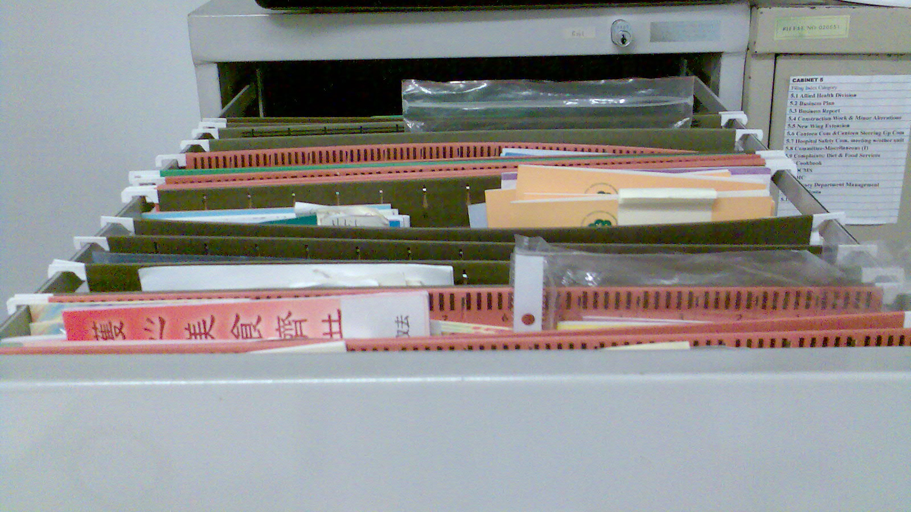
Figure 12a: The carbinet for storing pamphlets and handouts in Miss Hui’s office (Before re-organization)
(Source of the photo [Figure 12a]: By Chan Yuk Lin, Samantha, on 20 June 2007)

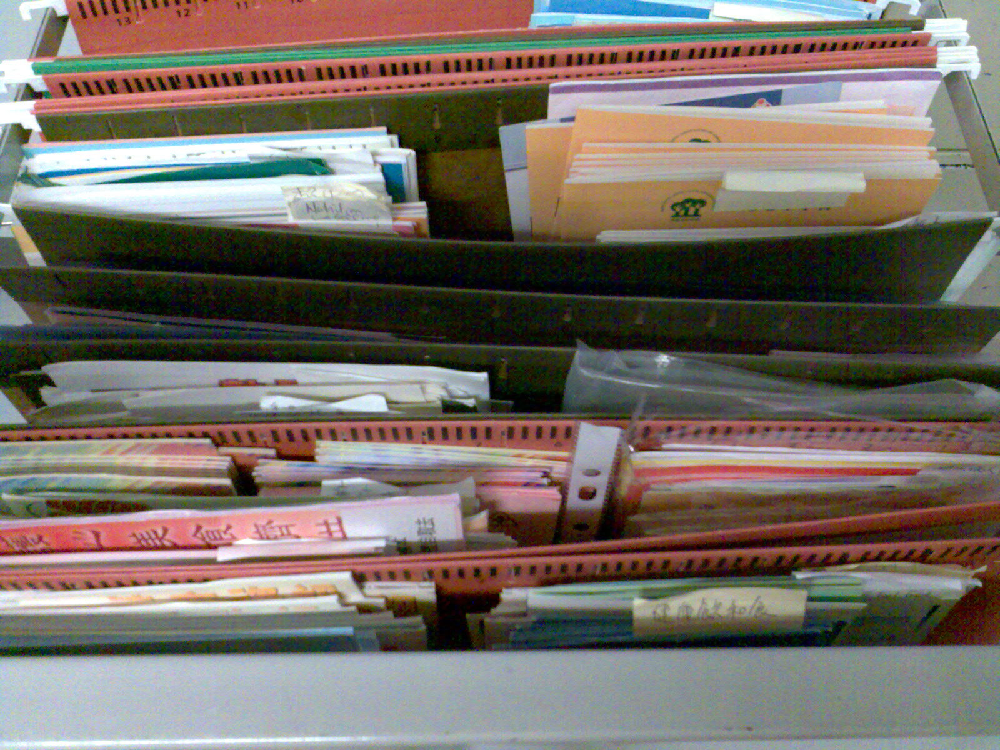
Figure 12b: The carbinet for storing pamphlets and handouts in Miss Hui’s office (Before re-organization)
(Source of the photo [Figure 12b]: By Chan Yuk Lin, Samantha, on 20 June 2007)

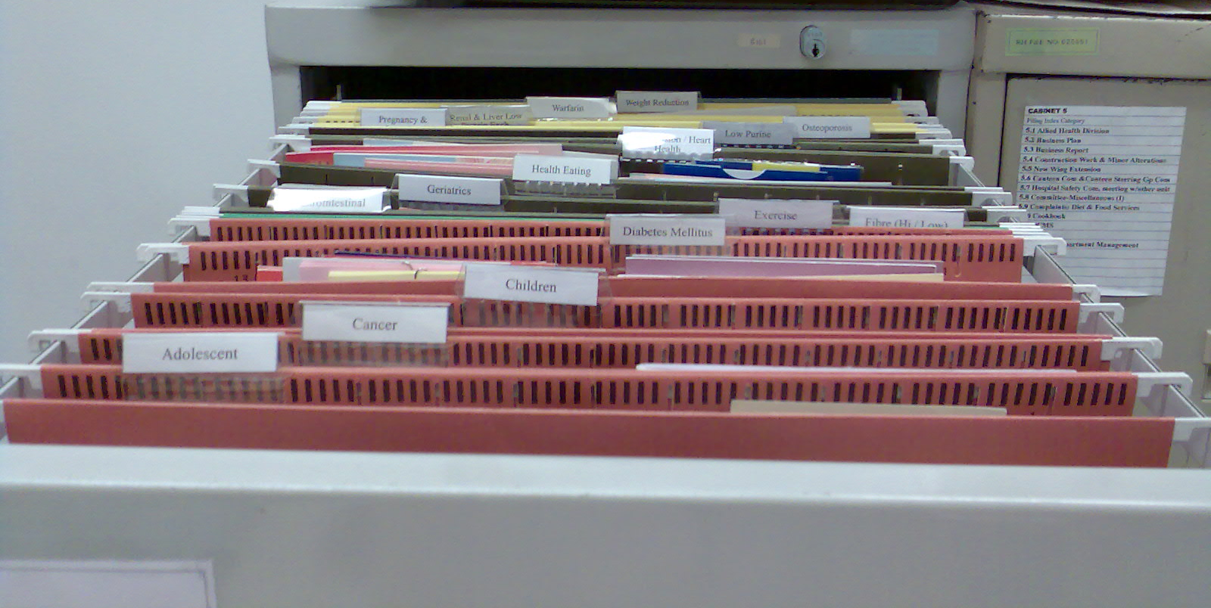
Figure 13a: The carbinet for storing pamphlets and handouts in Miss Hui’s office (After re-organization)
(Source of the photo [Figure 13a]: By Chan Yuk Lin, Samantha, on 25 July 2007)

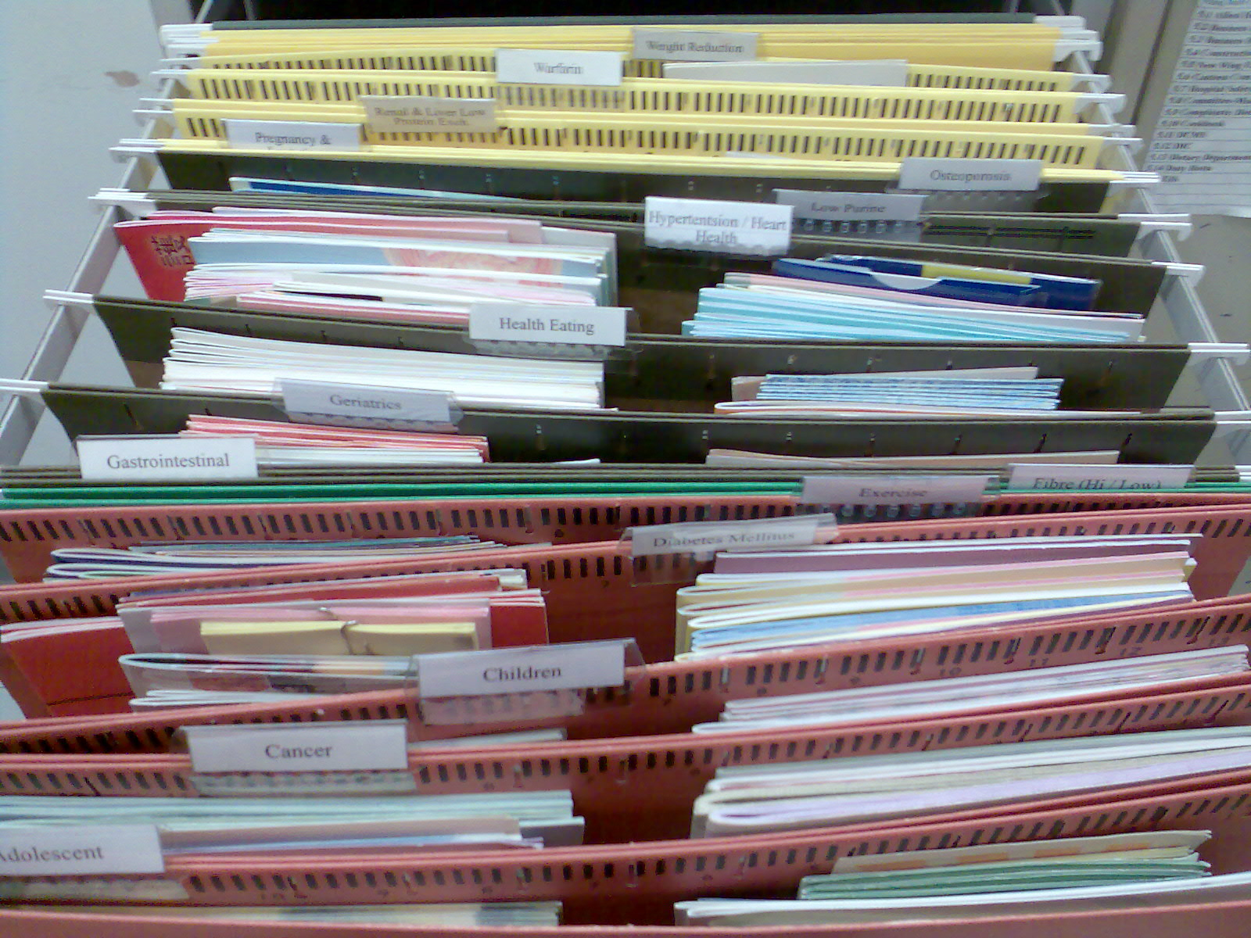
Figure 13b: The carbinet for storing pamphlets and handouts in Miss Hui’s office (After re-organization)
(Source of the photo [Figure 13b]: By Chan Yuk Lin, Samantha, on 25 July 2007)
Reflection of Example 1
Re-organization of the pamphlets and handouts is not an easy task since the original filing system is quite confused. For example, the classification labels are written by hand only. Besides, the labels are not listed in alphabetic order.
I think the introduction of the 5S concept is really suitable to apply in the workplace. Better organization and retrieval of information increases the working efficiency. According to the Occupational Safety & Health Council (2004), putting things in a proper order can eliminate negative impacts on work in progress resulting from having to search for such things as materials or tools


4.2 Example 2: Evaluation of the DIC Website Project
I would evaluate the Dietetic Information Centre (DIC) Website based on 3 aspects: system quality, information quality and service quality (refer to Figure 14).

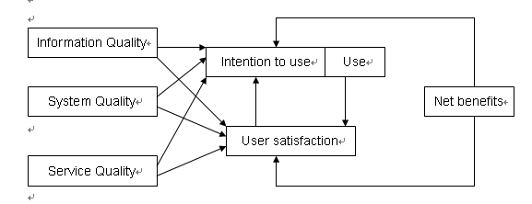
Figure 14: Updated DeLone & McLean IS Success Model (2003)

The major components of my evaluation report of DIC website project are listed as follows:
Constructs of system quality | Constructs of information quality
- Accessibility | - Accuracy of website content
- Usability | - Website content is understandable
- Functionality | - Website content is current
- Reliability
- Flexibility
- Communication

Constructs of service quality | Recommendation
- Perception of service quality | - Content Presentation
- Evidence of trust building | - Navigation

Reflection of Example 2
In order to do this evaluation report, I have to browse every part of the dietetic Information Centre (DIC) website carefully. It is really a valuable experience for me.
When I was creating webpages before, I developed the webpages from the view of webmaster / website designer. However, I have evaluated the DIC website from a customer point of view in this project. I think I have a better understanding on how to create a website that satisfy the users’ information need now.
I have also evaluated a website when I was doing an assignment during the study of High Diploma Programme in Library and Information Science. It is the website of the International Children’s Digital Library (http://www.icdlbooks.org/).
By comparing these two websites, they are quite different in purpose, target audience, content and structure. Website is an important platform for communication between the website service providers and its target audiences. User satisfaction has long been an important measure of website success. Evaluation should be conducted regularly so as to satisfy users’ information need.
4.3 Example 3: Induction to the Outpatient Services
Event: Outpatient Services
Date: 21 June 2007
Dietitian: Miss Hui
Target Participants: Patients with doctor’s referral

Observation to the Outpatient Services
In this afternoon, I observed my supervisor, Miss Hui’s duties on outpatient services. Usually, she would check patient’s record in the Clinical Management System (CMS). Then, she tried to have a better understanding by asking questions about eating habit. Finally, she would make some suggestions for the patients on how to regular their eating habits.

Reflection of Example 3
Some patients have a common problem in their daily life – not enough exercises. For the young patients, they usually concentrate on their work. For the elderly, they cannot do exercise regularly due to the painful feeling of different part of their bodies. I think we should pay attention to this problem when we are still young.

4.4 Example 4: Attend the Food Labeling Class (Basic)
Event: Food Labeling Class (Basic)
Venue: Seminar Room 3, LG1, Ruttonjee Hospital
Date: 28 June 2007
Time: 3:00pm – 4:00pm
Target Audience: Person with Diabetes Mellitus

The objective of the Food Labeling Class (Basic) is to teach the patients how to read the Nutrition Facts labels on the packaged foods.
Nutrition Facts usually list calories, total fat, cholesterol, total carbohydrate, sodium, and protein. Sometimes, Nutrition Facts also list the amount of vitamins, calcium, iron and other minerals. Each nutrient is followed by a number. This number is the amount of that nutrient in gram (g) or milligram (mg) in one serving of the food.
Food packages have an ingredients list too. Ingredients are listed according to their weight in the package. The ingredient weighting the most is listed first. The ingredient weighting the last is listed least. In fact, we should read the ingredients list because claims on packages can be misleading!

Reflection of Example 4
Reading the Nutrition Facts label and the ingredient list on the packaged foods will help us choose the healthiest (or the relatively healthier) among them.
They are such valuable information that we seldom pay attention to them. With more practice, we can become familiar with food labels. Then, we can get the nutrients we need.

4.5 Example 5: Observation to the Condemn Board Meeting of Allied Health Division
Event: Condemn Board Meeting
Venue: Seminar Room 5, 5/F, Block C, Ruttonjee Hospital
Date: 22 June 2007
Time: 12:00- 1:00pm
Participators:
- Miss Hui (coordinator of the 5/F Floor Allied Health Division, Dietitian i/c)
- Miss Lam (Podiatry I/c, HKEC coordinator)
- Mr. Ngan (Speech Therapy i/c)
- Mr. Shiu (representative of Human Resource Centre)
- Mr. Sin (Prosthetic & Orthotics i/c)

Reflection of Example 5
During the Condemn Board Meeting, I am assisted to observe the meeting dynamics. Due to the confidential problem, I should not deliver the detailed content of the meeting in any format.
However, I would like to point out some management problems faced by the hospital staff and these problems may also be faced by many other organizations and / or companies.

- Storage Problems
Due to the limited spacing, the Allied Health Division faced serious storage problems. It is important to handle the increasing numbers of documents and patients records.

- Staffing Resource Problems
The Government is now promoting the Five-Day Week. The participators also concern the availability of this new work pattern. However, careful planning and negotiation are needed since different department may have different working hours. It is important for the hospital to provide good quality of health care services to the public while introducing new working arrangement.

Appendix 1:
Hospital Background of the Ruttonjee and Tang Shiu Kin Hospitals
According to the webpage of Ruttonjee Hospital (Ruttonjee Hospital, 2007), the information about its background is listed as follows:
Hospital Background
Centrally located in Wan Chai, Ruttonjee Hospital (RH) is a recently- redeveloped hospital with a history that goes back more than 140 years. It was a naval and military hospital until 1949, when it had been converted into the Ruttonjee Sanatorium, with the support of Mr Ruttonjee and the Hong Kong Tuberculosis, Chest and Heart Diseases Association. Following a gradual decrease in the number of patients suffering from tuberculosis, the Government decided to strategically change it into a general hospital.
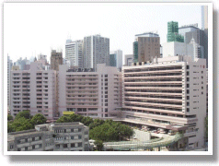

Figure A-1: Ruttonjee Hospital
Ruttonjee Sanatorium was renamed Ruttonjee Hospital in 1991 with a doubling of its former floor space area after completion of redevelopment. Three additional multi-level blocks and a rehabilitation garden were constructed. The scope of services has also been strategically adjusted to better meet the needs of the community. With more than 600 beds and 1000 staff, Ruttonjee Hospital provides specialist outpatient and hospital services. Its services include medicine, respiratory medicine, surgery and orthopaedic & traumatology as well as comprehensive geriatric care, with a day hospital, a specialist clinic, infirmary beds and community assessment services. A full range of allied health services are also available.
With effect from 1 April 1998, the management of Ruttonjee Hospital and Tang Shiu Kin Hospital (TSKH) has been integrated. The purpose of the integration is to amalgamate the management and the service provisions of the two hospitals to increase efficiency and to optimise the health care resource utilization. To further increase the service efficiency and for the benefits of the patients, the A&E Department, Tang Chi Ngong Specialist Clinic and other departments in TSKH were relocated to Ruttonjee Hospital in 2002 by phase. A 4-storey new block has been built on the podium level to accommodate the new departments.

Source:
Hospital Authority Web site,
<http://www.ha.org.hk/hesd/nsapi/?MIval=ha_visitor_index&intro=ha%5fview%5ftemplate%26gro
up%3dOSR%26Area%3dHNI>, accessed July 21, 2007.
Appendix 2:
Scope of Services of the Ruttonjee and Tang Shiu Kin Hospitals
According to the webpage of Ruttonjee Hospital (Ruttonjee Hospital, 2007), the Ruttonjee Hospital (RH) provides the following services:

Clinical Services:
- 24-hour Accident and Emergency Services | - Orthopaedics & Traumatology
- Anaesthesia | - Palliative Care
- Cardiac and Intensive Care Unit | - Pathology
- Radiology | - Plastic Surgery
- Geriatrics | - Respiratory Medicine
- Infirmary & Rehabilitation Service | - Surgery
- Medicine

Allied Health Services:
- Dietetics | - Physiotherapy
- Medical Social Service | - Podiatry
- Occupational Therapy | - Prosthetic-orthotics
- Pharmacy | - Speech Therapy

Other Services:
- Cardiac/Pulmonary Rehabilitation Programme | - Geriatric Day Hospital
- Chaplaincy and Pastoral Care | - Health Resource Centre
- Community Geriatric Assessment Service | - Special Accommodation Ward
- Community Nursing Service | - Specialist Out-patient Department
- Electro-medical Diagnostic Unit | - Volunteer Service

Source:
Hospital Authority Web site,
<http://www.ha.org.hk/hesd/nsapi/?MIval=ha_visitor_index&intro=ha%5fview%5ftemplate%26gro
up%3dOSR%26Area%3dHNI>, accessed July 21, 2007.
Appendix 3:
Organization Strucutre of the Hospital Authority
According to the webpage of Hospital Authority (Hospital Authority, 2007), the organization structure of the Hospital Authority is provided as follows:
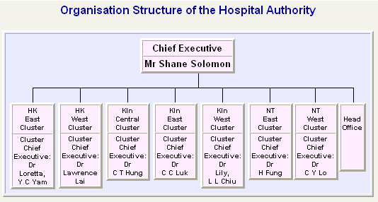
Figure A-2: Organization structure of the Hospital Authority
Source:
Hospital Authority Web site,
<http://www.ha.org.hk/hesd/nsapi/?MIval=ha_visitor_index&intro=ha%5fview%5ftemplate%26gro
up%3dAHA%26Area%3dANP>, accessed July 24, 2007.
Appendix 4: Introduction of SMRC model
This is the basic communications models, identified in 1949 by Shannon and Weaver, that distinguishes something of what happens between the person speaking (or writing, etc.) and the person listen (or watching, etc.).

Sequence
As for the basic sequence of this model, please refer to Figure A-3.
Source
Message
Channel
Receiver
Figure A-3: SMCR Model (Shannon and Weaver, 1949)

Source
It is the start of the communication, the person who encodes the message and transmits it to the receiver.
Message
It is the package(s) of meaning that contain the intent from the source. The message is what the source wants the receiver to hear and understand on a particular way.
Since we cannot connect mind together (even we want to do so), we have to translate the intent of the source into encoded message that the receiver can translate with reasonable accuracy.

Channel
It is the medium through which the message is transmitted. This is may be some forms of media such as television or newspapers. It may be direct channel such as telephone or face-to-face.
The channel must plug into the receiver’s sensory system, and hence may use sight, sound, touch, taste or smell.
Receiver
It is the person who is at the other end of the communication. The receivers may be actively seeking to receive the message pr may be surprised by it. They may be the intended target or just someone who is within receiving range. They will decode the message and create their own meaning.

Source:
Samantha Chan, “Asignment 3: Portfolio”, Course assignment, BSIM0001 Information
Management Foundations, 2006, p. 4 – 5.
Appendix 5: Introduction of Shannon – Weaver communication model
The most influential communication model is that used by Clande Shannon in 1948 to illustrate his communication theory. A number of adaptations have been made to Shannon’s communication model in order to make it describe communication in a more general sense.
According to Figure A-4, this representation of the model uses an approach to extend the provision for noise, incorporate provision for feedback and indicate the different levels at which information may be considered within the framework.
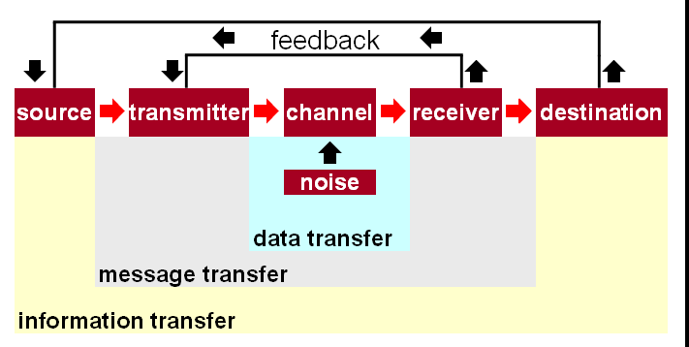Figure A-4: Adapted Shannon – Weaver communication model
(Source: Peter Warning, “Information concepts & models”, Lecture note, BSIM0001 Information
Management Foundations, 2006, slide 9)

The components in this model are:
- The source selects a desired message out of a set of possible messages.
- The transmitter changes the message into a signal that is sent over the communication channel to the receiver.
- The receiver is a sort of inverse transmitter, changing the transmitted signal back into a message, and interpreting this message.
- The message is then sent to the destination. It may be another receiver of the message may rest with the initial receiver, and the transmission is achieved.
- The noise can be internal (i.e. coming from the receiver’s own knowledge, attitudes, or beliefs) or external (i.e. coming from other sources). Such noise can either strengthen the intended effect of a message or weaken the intended effect.
- The principle of feedback has been incorporated in the model derived from that of Shannon, so that we may visualize a source modifying its message as a consequence of information received from the destination.

Source:
Samantha Chan, “Asignment 3: Portfolio”, Course assignment, BSIM0001 Information
Management Foundations, 2006, p. 6 – 7.

References
DeLone, W. H., & McLean, E. R. (2003). The DeLone and McLean model of information systems success: a ten-year update. Journal of Management Information Systems, 19(4), 9-30.

Hong Kong East Cluster, (2006, September 1). Organization Chart for Hong Kong East Cluster. Retrieved July 24, 2007, from Hospital Authority Web site: http://www.ha.org.hk/hesd/nsapi/?MIval=ha_visitor_index&intro=ha%5fview%5ftemplate%26group%3dOSR%26Area%3dHNI%26Subj%3dHKE&ustamp=2007%2d07%2d24+23%3a45%3a19%2e038

Hospital Authority [Hong Kong]. (2003). Dietetics & Catering Management System Diet Order Entry Module - User Guide Hong Kong: Hospital Authority.

Hospital Authority [Hong Kong]. (2004). Ruttonjee & Tang Shiu Kin Hospitals 2001 - 2004 Triennial Report. Hong Kong: Hospital Authority.

Hospital Authority, (2007). About Hospital Authority. Retrieved July 24, 2007, from Hospital Authority Web site: http://www.ha.org.hk/hesd/nsapi/?MIval=ha_visitor_index&intro=ha%5fview%5ftemplate%26group%3dAHA%26Area%3dANP

Liu, C., & Arnett, K. (2000). Exploring the factors associated with web site success in the context of electronic commerce. Information and Management, 38, 23-33.

Occupational Safety & Health Council [Hong Kong]. (2004). Good Housekeeping DIY Kit Hong Kong: Occupational Safety & Health Council.

Ruttonjee Hospital, (2007). Ruttonjee Hospital. Retrieved July 21, 2007, from Hospital Authority Web site: http://www.ha.org.hk/hesd/nsapi/?MIval=ha_visitor_index&intro=ha%5fview%5ftemplate%26group%3dOSR%26Area%3dHNI

Shannon, C. E. (1949). The mathematical theory of communication.
Urbana: University of Illinois Press.

Turban, E., & Gehrke, D. (2000). Determinants of e-commerce website. Human Systems Management, 19, 111-120.

Website of SmartDraw.com - http://www.smartdraw.com/exp/dfd/

- The End -

