Digital Libraries and Teens
Article submission to Library and Information Science Research journal

Ilene Zutty
Digital Libraries-e553
December 6, 2010

Digital Libraries and Teens
Ilene Zutty
School of Information and Library Studies, Rutgers University
New Brunswick, New Jersey

Abstract

The purpose of this report is to assess various digital libraries available to teens. Digital teen library sites and/or digital sites that have teen pages will be compared and evaluated. What are teens looking for in digital libraries? Do these sites satisfy this user community? Six different types of digital libraries will be compared based on a set list of criteria that include Content, Usability, and Service. The findings of this study are connected to previous research on teens and their interests and their use of digital libraries. This article outlines implications for teen information behavior and the Web on digital libraries, teens’ needs and expectations, and discusses suggested areas of further research.

1. Introduction

Teens have different online information search behavior than adults. They have had a lot more experience with technology than ever before. As teens continue to incorporate Web 2.0 technology into their everyday lives, we need to examine how the digital library community is servicing their needs. Are these sites supporting the needs of teens?

According to Joyce Valenza “young information seekers are most successful when they are interacting with systems designed for them, when they have effective system feedbacks and graphic visualizations”. (2006, p.23)

Previous research has shown that teens respond to Web pages that have meaning for them, and digital libraries need to include what interests these teens in their sites. ”Although young adults make up approximately one fourth of library users (U.S. Department of Education, 1995, p.2), only about 20% of public libraries have developed Websites designed to meet their needs” (Firestone, 2002). This indicates that there is a gap when it comes to libraries’ websites and teens. Online libraries have a great opportunity to engage teenagers if they have the knowledge of teens’ expectations and user needs.

This report evaluates and compares six different digital libraries. These digital libraries are a mix of public libraries, a school library, digital sites, and subject specific sites. The libraries examined in this study are the Denver Public Library http://teens.denverlibrary.org/), Los Angels Public library(http://www.lapl.org), IPL(Internet Public Library) (http://ipl.org), Nemours Science Center http://www.kidshealth.org), Springfield, PA school library
http://springfieldlibrary.wikispaces.com/ ,http://www.sdst.org/shs/library), and the National Science Digital Library (http://nsdl.org).

2. Past LIS Research on Teens

The Needs of Teens

Minudri and Goldsmith (1999) compiled a list of guidelines to help librarians meet the needs and interest of young adults based on their experience with them at Berkeley(CA) Public Library. Among the most notable guidelines was that libraries need to seek the advice of teens. Suggestions included creating a teen advisory council, and a survey of what they’re looking for. Another piece of advice was to respect what they say. Equally important is to provide guides to your library’s resources that are easy to use, including pathfinders to help them find what they need efficiently.

In 1999 Elaine Meyers conducted a focus group to determine what teens were looking for in a library. She based this study on Peter Zollo’s Wise Up to Teens: Insights into Marketing and Advertising to Teenagers. Zollo found that teens associate quality with what they consider “cool”. If it’s cool, they’ll use it. Meyers studied four aspects of library services: technology, staff service, space and materials. She found that teens want help with their projects in school and their research, and that the hours the library was open was not convenient for teens. She also found that teens were willing to help make their libraries better.

Teenagers and Searching

Joyce Valenza (2006) is a well known school librarian in Springfield, PA. In her article, “They Might be Gurus”, she states, “young information seekers do not appear to have the sophisticated skills or understandings needed to navigate complex information environments and evaluate information they find”(p.18).

Students are actually somewhat limited in their understandings of the way results are returned on a search and how information is organized. Students assume that searches will “understand the sentences and questions that they enter into search boxes-that is, natural language style” (p.18).

“Young users prefer collaborative seamless environments. Their academic, social, creative and entertainment merge online, in nomadic multitasked landscapes..The concept of leaving a favorite search tool and going to a scholarly database for one task and to a Web portal for another is antithetical to the way they prefer to work and play (p.21).

Valenza also noted that students have trouble naming their information needs (Brown, 1995; Large & Beheshti, 2000). Students also spend more time searching than evaluating what they have found. First year college students prefer commercial search engines to academic or library sites.(Jones & Madden, 2002).

Carol Kulthau’s work on how we search discusses the emotions and attitudes that come along with it. Students bring confusion and doubt into their information search process (2007). Kalbach (2003) noted that that this holds true for information seeking on the Web as well. “Students experience the frustration of information overload within both text-heavy individual sites and the Web as a whole. They avoid text-intensive sites in favor of sites with bullets and graphic content”(Valenza, p.20).

Bilal(2002) found in a study on the search engine Yahooligans that seventh grade students were more successful in self generated tasks vs. imposed tasks.
She concluded that the students’ interest and familiarity with their topic contributed to the success of the self generated task. They showed higher levels of motivation when they were involved in the selection of the topic as well as the task.

Teenagers and the Internet

There are at least 17 million youth from ages 12-17 using the Internet (Hughes-Hassell and Miller, 2003). According to Teenage Life Online (Lenhart, Rainie, & Lewis, 2001), the Web has mostly replaced the library as the primary research tool for projects, and 71% of the teens surveyed relied mostly on Internet resources for their research. The number one reason for using the Internet was the speed of online searching.

According to Agosto (2002) who studied young adults and the Web, students were bored and indifferent to test sites that they visited. Agosto concluded that the participants found them boring because these sites were designed by adults, who used their own criteria for evaluation, rather than considering youth preferences. High school students like surfing the net because it provides a lot of visuals, a variety of formats, and easy access to information they need (Fidel et al. 1999).

Libraries and their Websites
Jones, in his survey of online teen libraries, “A Cyber-room of their own”, states that young adults respond best when they have their own space. According to Jones, less than 60% of public libraries have a separate young adult collection in a separate space, and this is also true of teen spaces online. Teens want from their virtual space what they want from a physical space-materials that are of interest to them, and a space that is attractive and unique from other parts of the site, by clearly defining the teen audience through its appearance, scope and content.(p.1) Jones also found that every one of the libraries that involved the teens in the development of a teen page had positive results. He also noted that the sites that had the best links, content, and design were those that had teen assistance (p.4).

Jones and Pfeil (2004) review what the public library young adult web page will look like for the 21st century. They stress “for teen sites to be relevant, they have to be current” (p.15). This includes topics of interest to teens outside of the school area such as sexuality, teen violence, teen pregnancy and suicide. This also means having the most current Web 2.0 technologies that teens use in everyday life, such as blogging, video games, podcasts, etc. The authors suggest the best way to keep current is to involve the teens in the design and creation process of the website, and to have them evaluate it.

Teens use the Web not only for research but for social purposes. According to Ebenkamp(1999), “this attitude can have great implications for Website design and software evolution”(p.18). “Library web pages must address the needs of young adults on many levels-academic, social, and recreational. The social and recreations aspects may be critical in assuring a return visit”(Hughes-Hassell and Miller, p.145). Jones(2002) notes that some libraries feel this is a waste of time, but this has been proven not to be the case. The interactivity of the Internet such as email and instant messaging allows teens to “discover methods for connecting positively with peers and adults, to determine their value systems, to be socially competent, to improve their self image, and to learn a new skill or topic”(p.18).

Hughes-Hassell and Miller (2003) conducted a study to determine if public library websites were meeting the needs of today’s teens online. Among their findings was that teens will visit the Web pages they feel are relevant to their own lives. They also found that there were only three librarians who reported that their Web pages supported interactivity. Braun (2002) says this could be because the librarians do not have the technological know how that the teens do. Another factor in the lack of up- to-date trends on the website may be that librarians are competing against what is viewed as the library’s mission as a whole from administration.

The authors also found that if libraries want to engage the young adults to use their website, they need to involve the teens in every aspect of the site development including planning and implementation. Braun (2002) also recommends paying attention to teens’ interests when designing the “look” of the site. Libraries should use colors and visuals that appeal to teens; this will show them that they value their needs and interests. Evaluating how the website is working should be continuous, and the sites should be updated to reflect new trends in technology and teen interest. All of these factors will encourage teens to become lifelong users of the library (p.155).

Hughes-Hassell and Miller also found some obstacles to successful web pages.
They found some of these were insufficient funding or time, not enough staff or training, and administration restraints.

Church (2006) stresses that a school library web page represents that library outside of the “school walls”. It not only provides a space for students to learn, but also promotes the library’s visibility. Church suggests using the library’s site to promote reading and research. Her recommendations for engaging students include putting extras on the online catalog such as indicating book award winners, links to author sites, providing e-books and online games, and book blogs To support research she recommends subscribing to online databases, provide curriculum related website links, pathfinders, and search tools. Church claims that “we must meet the students needs virtually, providing sources and services at the point of need”(p.13).

Ross Todd (2008) encourages school libraries of the future to embrace the new Web 2.0 technologies that teens are using to engage them. He states that that using these social network tools creates a new challenge for school libraries “to understand actual behavior of today’s young people in their information landscape. They are voracious users of all forms of digital media, developing new forms of online reading patterns, actively contributing to the content explosion on the Web..To not do this is to make school libraries even more marginal to the world of young people” (p.31).

This study seeks to compare and contrast digital libraries and teen pages on the Web. It will explore whether the information needs of teens are met, if they are promoted towards teens and their ease of use.

3. Methodology

3.1 These following digital libraries were evaluated according to a set of criteria listed below in section 3.3. The digital libraries represent a mix of public libraries, a school library, digital sites, and subject specific sites. They are:

- Denver Public Library
http://teens.denverlibrary.org/
- Los Angels Public Library
http://www.lapl.org/ya/
- IPL(Internet Public Library)
http://ipl.org/div/teen/
- Nemours Foundation
http://www.kidshealth.org
- Springfield, PA school library
http://springfieldlibrary.wikispaces.com/
http://www.sdst.org/shs/library/
6. National Science Digital Library
http://nsdl.org

3.2 The digital libraries were measured subjectively by the author of this study via a rankings system. The scale 1-5 was used-1 indicating least agreement, and 5 indicating most agreement.

3.3 The digital libraries were examined based on the following criteria:

Content
- Timely-is the information current?
- Quality for teens and valuable for them-do the collections fit with teens?
- Complete-what is its scope?
- Reliable and accurate
- Style of collection-is it organized? Layout? Presentation?
- Educational content-does it relate to school work?

Usability
- Ease of use (of interface)- simple navigation
- Search and browse function
- Help features
- Accessibility

Service

- Uniqueness-does it provide anything different, updated with new trends?
- Interactivity- via blogs, chat, instant messaging, etc
- Traditional library services and Reference services-does it provide on demand? Are there pathfinders and tutorials?

4. Findings

Table 4.1 Content

Content-The highest ranking went to the Springfield School Library. The library that ranked the least in content was the Los Angles Public Library. The teen page received a low ranking on content because in order to explore resources relating to actual books for projects, the user was redirected to the main library page. It would have been much more effective if a search keyword box appeared directly on the teen page.

The highest ranking within the content criteria went to “collection quality for teens”. This finding shows that the content for teens is there, however the manipulation and organization of it needs to be improved for teens.

Table 4.1
Content
 | Denver | Los Angeles | Internet | Nemours Sci Ctr | Springfield | Nat'l. Sci | Total
 | PL | PL | PL | Kidshealth | SL | DL
Timeliness-info. current? | 5 | 4 | 4 | 5 | 5 | 4.5 | 27.5
Collection quality for teens | 5 | 4 | 4 | 5 | 5 | 5 | 28
Completeness | 5 | 3 | 4 | 5 | 5 | 4 | 26
Organization | 4 | 3 | 4 | 5 | 5 | 4 | 25
Layout | 4 | 3 | 3 | 4.5 | 5 | 2 | 21.5
Educational content-relate | 5 | 4 | 4 | 3.5 | 5 | 4.5 | 26
to school work?
Total Ranking | 28 | 21 | 23 | 28 | 30 | 24
PL=Public Library
SL=School Library
DL=Digital Library
subjective measures
1=in least agreement
5=most agreement
(Xie, 2007)
(Zhang, 2009)

Table 4.2 Usability
Usability-The Springfield School Library was the most usable, with Kidshealth.org ranking a close second. This is an interesting finding because Kidshealth is not a library, or a school. It’s a subject site geared toward getting information out to the everyday person. It makes sense that this site is very usable, because it aims to reach a variety of people and not just students or academics.

The highest usability score within the criteria was that the”links were easy to follow”, however, the lowest score went to the “overall ease of search”. This shows that teen sites need to take into account that teens are used to browsing more than searching, and prefer a more seamless search task. While the links were present and working, for many of the sites the search task took you back and forth in and out of the sites.

Table 4.2
Usability
 | Denver | Los Angeles | Internet | Nemours Sci Ctr | Springfield | Nat'l. Sci | Total
 | PL | PL | PL | Kidshealth | SL | DL
Easy to get started (searching) | 5 | 3 | 4 | 4.5 | 5 | 4 | 25.5
Easy to get started on browsing | 4 | 4 | 4 | 5 | 5 | 4 | 26
Results list easy to read | 4 | 4 | 4 | 5 | 5 | 2 | 24
Overall ease of search(browse) | 3 | 3 | 3 | 5 | 5 | 2 | 21
Links easy to follow | 5 | 4 | 5 | 5 | 5 | 3 | 27
Made great effort to accomplish task | 1 | 2 | 2 | 1 | 1 | 4 | 11
Good Help Features | 1 | 1 | 5 | 5 | 5 | 4.5 | 21.5
Total Ranking | 23 | 21 | 27 | 30.5 | 31 | 23.5
PL=Public Library
SL=School Library
DL=Digital Library
subjective measures
1=in least agreement
5=most agreement
(Xie, 2007)
(Zhang, 2009)

Table 4.3 Service
Service-The Springfield School Library ranked highest in service. This is a teen supported, teen oriented site that has really taken into consideration its users. The traditional services combined with interactivity and overall usefulness make this an outstanding site. The Internet Public Library ranked second in service. This makes sense because the IPL is servicing online customers. It needs to ensure that it provides interactivity, and is updated with the newest trends in virtual librarianship. The least ranked in service was the National Science Digital Library. This library, while maintaining accurate content, is a basic website that has not incorporated a lot of the new technologies or interactivity teens are looking for.

Within the Service criteria, it was found that the sites did do a good job of providing “interactivity” and a “space for feedback”. This is very encouraging considering much of the research has emphasized the need for teen input in design and development. The teens use new Web 2.0 technology in their daily lives, and it seems from the data that the sites are picking up on this trend, and incorporating that into their own sites. One area that does need to improve however is the “reference services on demand”, especially for the Kidshealth.org site and the NSDL, both are which are the subject specific sites. This was a surprising finding, since they are subject sites they do have the content and information, but are not getting it to their users quickly enough.

Table 4.3
Service
 | Denver | Los Angeles | Internet | Nemours Sci Ctr | Springfield | Nat'l. Sci | Total
 | PL | PL | PL | Kidshealth | SL | DL
Uniqueness-anything new | 4 | 3 | 4 | 3 | 5 | 2 | 21
or different?
Updated with new trends | 4 | 2 | 5 | 4 | 5 | 2 | 22
Interactivity | 5 | 4 | 5 | 4 | 5 | 2 | 25
Provides traditional library services | 5 | 4 | 3.5 | 1 | 5 | 3.5 | 22
Reference services-on demand? | 5 | 3 | 4 | 1 | 5 | 1 | 19
Overall usefulness | 4 | 3 | 4 | 5 | 5 | 3 | 24
Space for feedback? | 3 | 5 | 4 | 5 | 5 | 3 | 25
Total Ranking | 30 | 24 | 29.5 | 23 | 35 | 16.5
PL=Public Library
SL=School Library
DL=Digital Library
subjective measures
1=in least agreement
5=most agreement
(Xie, 2007)
(Zhang, 2009)

5. Discussion

  - Digital Libraries

Figure A. Denver Public Library Teen home page
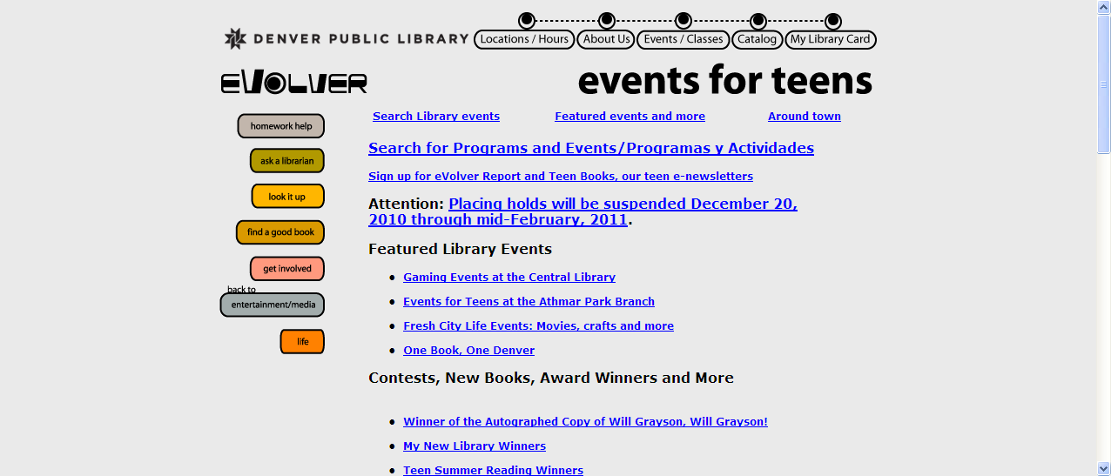

The Denver Public library had a visually interesting teen page. The content and service scores were quite good, with usability scores dipping. The site seemed to have all the bells and whistles a teen would like, including its name “Evolver”, however, some of its usability functions could have been better. The overall ease of navigation could have been much better. There were two options on the teen home page-“look it up” and “find a good book”. At first glance you really weren’t sure which served what purpose.

The “find a good book” feature was up front and visible (easy to get started) but the overall ease of search was scored a “3” because you were not directed right away to the catalog. Also, when searching by subject, the user was directed by a pre- determined set of subjects rather than the user entering their own subject term.

In the Usability table the “Help” features scored a rating of “1” because there were no identifiable help features at all. In the Service table the “Space for feedback” also received a lower score because there was a very small link at the bottom of the page for suggestions and feedback that you could not see right away, unless you knew to scroll down to view it.

Figure B. Los Angeles Public Library Teen Web home page 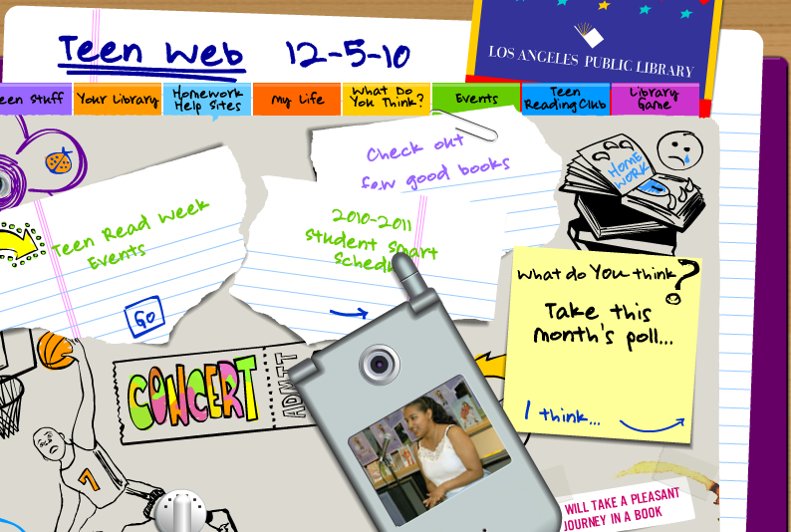

The Los Angeles Public Library teen page had a terrific visual home page, appealing to teens with ripped looking notebook pages and cell phone. The links included guiding teens towards a “Just for Girls” page, “Just for Guys”, movies and TV, comics and art, sports and video games, and books. While it was great to look at, it was hard to determine which icons you could click on to get you someplace else on the site. It also took a few moments to load. Once you clicked off the home page however, the pages were extremely basic and dull. There was a consistent icon indicating “LA Public Library” however, in the Content table the Organization was given a “3” because when in the “your library” section on the teen page, there was no direct link to the LAl library catalog within that page.

There was also no direct link to the library catalog in the “homework help” section. If you needed to use the “LA Public Library” icon to get to their catalog you were kicked out of the teen pages you had been in originally. In the Usability table the “Easy to get started” and “Overall ease of search” were given “3” because on the teen home page it was very hard to tell which icons were actual links to the rest of the site, and therefore there was no easy way to start searching.

For the “Service” Table the “Updated with new trends” was given a “2” because there was no place for teens to chat, blog or create. The” Reference” and “Usefulness “criteria were also given “3s” because there was no 24/7 feature for instant messaging or resource help. There was a homework help function but services were limited to certain times of the day. There was also no help feature. The LA teen space was given a “5” for Feedback because there was a section called “What do you think?” for the teens to provide reviews of books, suggestions, and a “You have Spoken” feature which lists results of polls they’ve conducted including teens’ comments and “hot topics”.

Figure C. Internet Public Library Teen home page
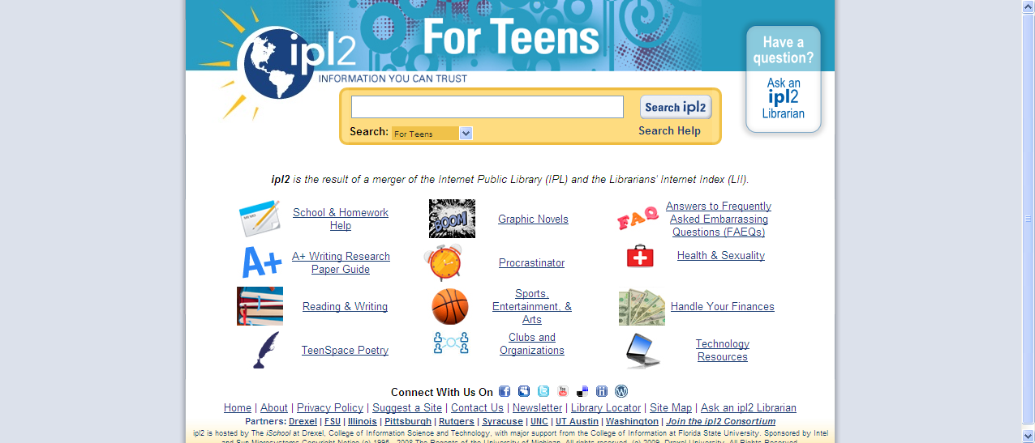

The Internet Public Library teen page had a home page with different icons that made it clear what they were, and easy to search. On the teen home page there were links to such teen topics as TeenSpace Poetry, sports and entertainment, graphic novels, handling your finances, and homework help. While the information for teens was there, the layout after the homepage was very basic and not very engaging to teens. This site could make use of teen input, and add graphics that would entice teens to investigate further. While there was an obvious “search” function and a search help function, it was difficult to figure out what to search for.

This author tried searching by a title of a book, and did not get any relevant results. The search function was very detailed and helpful, but it did not explain what items to search for vs. what not to search for. The Usability table listed “Overall ease of search” as a “3” because once you left the teen page you had to start at the beginning to get back to it. It was easy to end up at the IPL general site, but not get back to the teen site.

The Service table indicates high scores for “Interactivity”, “New trends”, and “Uniqueness” because the user is able to contact the IPL via Facebook, Twitter etc. The “traditional library services” are there, but again, the search for actual listing of helpful texts was not there. The rating here therefore, was 3.5 The “Ask an IPL Librarian” is a 24/7 service, however, it takes up to three days to get a reply.

There was however, “Frequently Asked Questions” page which did direct you to this type of information, but the questions were pre-set. The IPL teen page also had a “Suggestions for Sites” page where you could add recommendations of website resources. It also had a “Thing of the Week” page where “Procrastinators’ have space to write an answer to a question of the week. Responses are then posted.

Figure D. Springfield Township Virtual Library home page
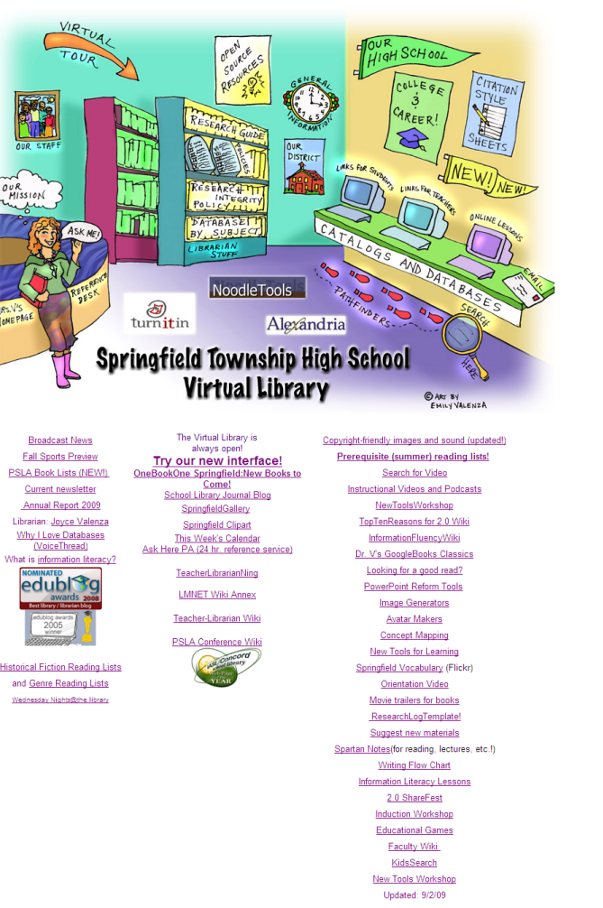

The Springfield high school library site was geared for teens at every level. The animation on the site was enticing, using icons that looked like notebooks. The school library had what it referred to as a “traditional site”-the Springfield Township High School Virtual Library(above), and then a link to its new interface, a wiki. Both home pages had very clear visual icons to click on to enter a vast amount of links and pathfinders. On the library home page the catalogs and databases links were portrayed as an illustration of a desk with computers, one for links for students, one for teachers, and one for online lessons. Pathfinders were indicated by footprints, and a picture on the wall was a link for staff information. On the more traditional site there were links about the district, college information, and citation information. Searches were all present on the home page, which made the site very user friendly and easy to navigate.

There were many spots to contact the school librarian via chat, blog, email, and twitter. There was a 24 hour reference service available. The site included new services such as ebooks, and offered a guide to free ebooks and textbooks. Information literacy guides were predominant here as well. Tips for students on citations, powerpoint instruction, video and podcast creations, and concept mapping were all available on the home page.

Figure E. Springfield High School Library Wiki

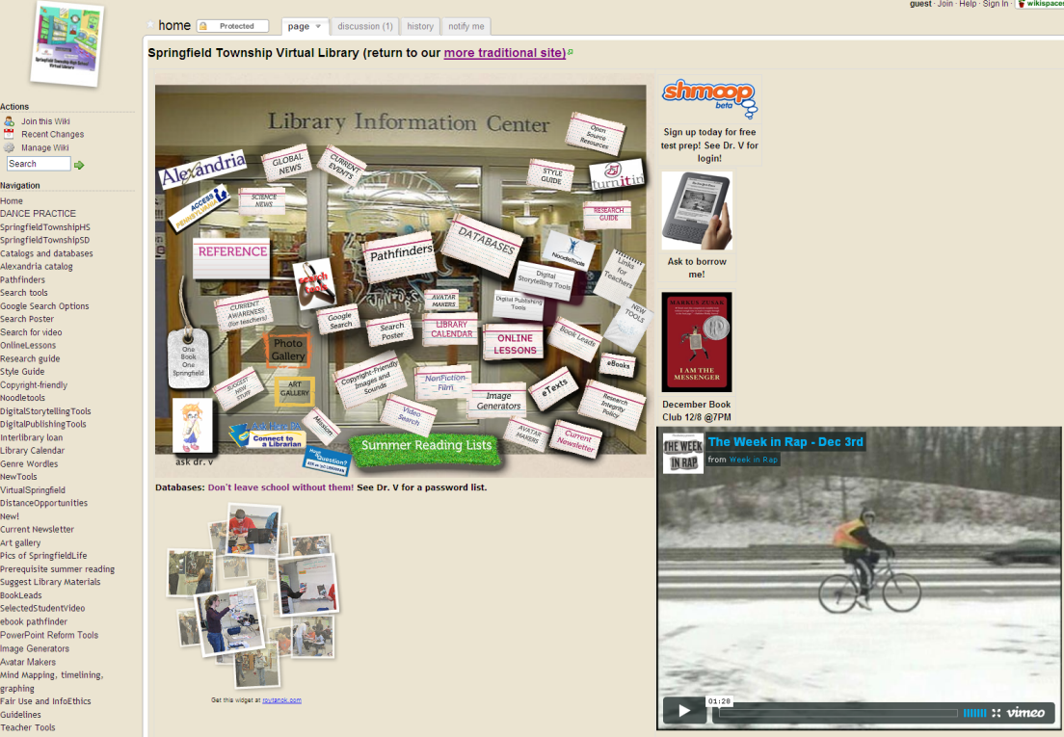

The wiki offered everything the traditional home page offered, and included a place for discussion, blogs, videocasts, as well as notifying the school librarian. The icons were self explanatory and comprehensive. There were video links to the Washington Post, Twitter, etc. The representation of the information was unique and with a teen feel.

The site has earned the highest score in each category because the user found the content, service and usability to be exceptional, and a model for digital teen libraries of the future. This site was well thought out with a design, interface, interactivity, and graphics with teens in mind.

Figure F. Kidshealth.org Teen page
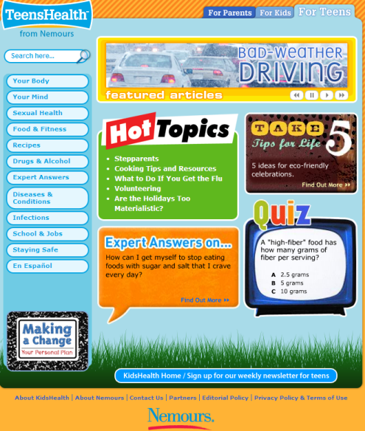

The Nemours Science Center maintains the Kidshealh.org site via the Nemours Center for Children’s Health Media. The Nemours Science Center is a nonprofit organization dedicated to improving the health of children. Teenshealth is part of the Kidshealth.org website, and offers medical information to teens as well as information about life and emotions. It is a subject specific site.

The home page of teenshealth offers links to hot topics, expert answers on typical teen questions, life tips and health quizzes. It also offers a good variety of subjects to search on, as well as a keyword search box. Once you enter a topic, you are prompted to delve further into the topic. Once you click on the prompt, you may find a personal story, a sound byte, basic information, links for further investigation, and links to Facebook, Twitter, Diggthis, Delicious etc.

For Content the site received a “4.5” for site layout because it looks like it’s trying to appeal to teens, but it just a little short in the visuals. The sidebar section has links for each topic and once you click the topics a very basic list emerged. Adding more visuals here would be more effective for teens. The site has basic information on a variety of topics such as diseases and conditions, drugs and alcohol, your body, infections, etc. The site makes clear that it is not necessarily for school research, but geared toward a teen’s personal interest, therefore, it received only a “3.5” for “Educational content related to school work”. It would be a good place to seek however, for some background information on certain school topics.

The site is user friendly and results are easy to read. There are links such as “Contact Us” for more information. The rating therefore for “Overall usefulness” and “Space for feedback” was “5”. The site rated low on “Traditional library services” and “On demand services” because it is not set up for these types of requests. A suggestion would be to at least provide a link for users to go to if they needed immediate information or feedback on a topic. While the site did have links to Facebook and Delicious, there could be more Web 2.0 technology incorporated such as blogs for teens to communicate with each other, especially on health and personal issues. The score here therefore was a “3”. An interesting and unique feature of this site however was an option to see this information translated into Spanish.
Figure G. National Science Digital Library
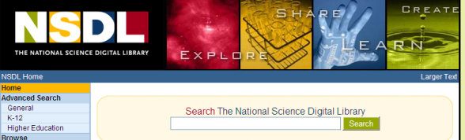a. NSDL Home page

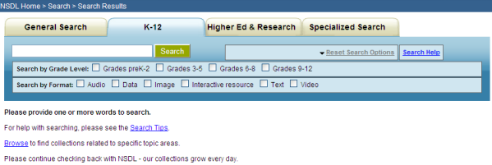
b. NSDL K-12 page

The National Science Digital Library is a subject specific site. The NSDL is a national library for research in science, engineering, math and technology. On its home page the site offers search options for children K-12(a). While the content was there, the information was extremely dry. The section for kids K-12 seems like just another way for the site to break down the material(b). The information is accurate and school related. The layout rating of “2” reflects that the site had nothing visual to differentiate the teen page from any of its other pages.

The usability was mixed. The site did have a good help feature, however you needed to scroll down to the bottom of the page to find it. The help included help for first time users, collections, glossary, search tips and results. This was a general help link that was not directed towards teens. The “Results list” , “Overall ease of search”, and “Links easy to follow” received ratings of “2 and 3” respectively because there was no option to narrow the search, except for searching in a designated “specialized search”box. This was a search by a broad topic. The search results were cumbersome. If you were to start with Advance Search however, you could have the option to narrow the topic and age range. The Advance Search feature ,however, was not an option when you are already in the K-12 search area, but only offered on the site’s homepage. The option to do this was not made clear. For a beginner, this search could be very overwhelming and confusing. Once you received an initial results list, there were links to take you to other areas, such as The American Museum of Natural History. The user is taken out of the site completely, but pressing the back button did take you back to their site. Teens expect information quickly and do not want to be taken back and forth, so this is a feature that would not appeal to them at all.

While the NSDL site provides a subject specific service, there was nothing unique or particularly current about the site. The site did have a section in the middle of the K-12 page called Highlights, where students could leave comments. These comments can be followed through an RSS feed. The interactivity and currency of the site was lacking. While there was an NSDL wiki, it was not geared toward teens. There were no on demand services or chat options. There is a lot of useful information on the site, but not tailored enough for teens. The “Space for feedback” is on the general site, and not tailored specifically to any subject or broken down into any type of structure. These therefore received a rating of “3”.

5.2 Satisfaction
Satisfaction is a criteria that is not included in this study. Not all users are the same, and the author of this study is not a teenager. Satisfaction is very subjective. The criteria used in this study were based on previous research on the needs and preferences of teens, along with what teens are looking for in digital libraries. A teens’ evaluation of these sites may be completely different than that of this author. Their preferences, experience and knowledge of how to search are different. Teens have grown up as the “Google generation”. They have been virtual users since they were young. Their expectations are different. The study however is useful because teens’ needs are recognized and the criteria were set up with their needs and interests as the focus of the rankings.

6. Conclusion

“Today’s youth are also the future of public libraries in this country. By developing young adult Websites that not only address the developmental needs of teens but also respect their knowledge of Web technologies and Website design, librarians can encourage teenagers to become lifelong supporters of libraries”(2003, p.155)

According to Patrick Jones, teens today and of the future are the first “wired generation”. “To many, computers and the Internet are nothing special or different-they’re just art of daily life” (1997, p.5) In order to engage teens to respond to teen directed sites, their needs need to be integrated into the site. Teens need to be involved in the creation, design and layout of the site. Digital teen libraries of the 21st century need to incorporate the most current Web 2.0 technologies to attract teens and show them that their interests are being considered.

Joyce Valenza claims that teens “may not be gurus” after all. They are facing a World Wide Web consisting of million upon millions of pages set up primarily for adults. Teens are more confused than we think, and we need to learn right along with them. Teens need to be prepared to be efficient and effective users in the digital world (2006, p23)

If digital libraries want teens to stop by their sites first, they need to meet the expectations and needs of this user community. It has been shown that teens respond to feedback from a system, graphic visualizations, and a design that was created specifically for them (Valenza, 2006). As teens incorporate more technology into their lives, the digital library community needs to examine how we are servicing their needs. Website developers need to consider which interactive technologies should be incorporated and how best to serve the information seeking behaviors of teens online(Hughes-Hassell and Miller, 2003).

This study was an exploration into various existing digital teen sites and/or pages. An examination and comparison of public, school, subject specific, and digital libraries was conducted. The limitations of this study are obvious, there was only one subject examining these sites, and the subject is not a teenager. The questions raised and the results however, warrant further examination. Most of the past studies regarding teens and digital libraries have focused on the digital libraries themselves and their designs. Xie’s study in 2008 on users’ evaluations of digital libraries is a good exception. The users in this study were not teenagers but adults.

A suggestion for further research would be to gather a sampling of teenagers from different backgrounds and have them compare and evaluate a set of digital libraries that have been provided for them to view. The study should focus on the teens’ evaluations, rather than just the design of the digital library.The teenagers would be given a variety of searching tasks. A survey or focus group should be conducted to see what they feel are the positive and negative aspects of these sites, and a comments section on what they feel is lacking should be included. The teenagers could keep diaries to track their search and browsing experiences. The information seeking behavior of teens is a necessary and valuable information when creating a digital library specifically for them.

Sources

Agosto, D.E. (2002). Bounded rationality and satisficing in young people’s Web-based decision making. Journal of the American Society for Information Science and Technology, 53, 16-27.
Bilal, D. (2002) Children’s use of the Yahooligan! web search engine. III. Cognitive and physical behaviors on fully self-generated search tasks. Journal of the American Society for Information Science and Technology, 53(13), 1170-1183
Bilal, D., & Kirby, J. (2002) Differences and similarities in information seeking children and adults as web users. Information Processing and management, 38(5), 649-670.
Braun, L.W. (2002). Teens. Library: Developing Internet services for young adults. Chicago, IL: American Library Association.
Brown, M.E. (1995). By any other name: Accounting for failure in the naming of subject categories. Library and Information Science Research, 17(4), 347-385.
Church, A. (2006). Your library goes virtual: Promoting reading and supporting research. Library Media Connection, (November/December), 10-13.
Ebenkamp, B. (1999). Cyber teens get social. Brandweek, 40, 18-22.
Fidel. R., Davies, R.K.., Douglass, M.H., Holder, J.K., Hopkins, C.J., Kushner, E.J., Miyagishima, B.K. & Toney, C.D. (1999). A visit to the information mall: Web searching behavior of high school students. Journal of the American Society for Information Science, 50, 24027.
Firestone, T. (2002). The virtual YA Index: Public libraries with young adult web pages. http://yahelp.suffolk.lib.ny.us/virtual.html
Harris, C. (2009). Excuse me, do you speak digital?: Harvard's john palfrey explores what it's like to be a digital native. School Library Journal, (November)
Hughes-Hassell, & Miller, E. T. (2003). Public library websites for young adults: Meeting the needs of today's teens online. Library and Information Science Research, 25, 143-156.
Jones, P. (1997). A cyber-room of their own. School Library Journal, 43(11), 34-38.
Jones, P., & Pfeil, A. (2004). Public library YA web pages for the twenty-first century. Young Adult Library Services(YALS), (Spring), 14-18.
Jones, S. & Madden, M. (2002). The Internet goes to college: How students are living in the future with today’s technology. Pew Internet and American Life Project website: www.pewinternet.org/report_display.asp?r=71.
Kalbach, J. (2003). “I’m feeling lucky”:The role of emotions in seeking information on the Web. Retreived from Valenza(2007), http://home.earthlink.net/~searchworkshop/docs/Jkalbach_Emotions-informationSeeking-Web_short21.pdf
Kulthau, C.C. Guided Inquiry: Learning in the 21st Century, Libraries Unlimited: Santa Barbara, CA, 2007.
Large, A. & Behesti, J.(2000). The Web as a classroom resource: Reactions from users. Journal of the American Society for Information Science, 51(12), 1069-1080.
Lenhart, A., Raineie, L., & Lewsi, O.(2001). Teenage life online:The rise of the instant-messaging generation and the Internet’s impact on friendships and family relationships. Washington, D.C.: Pew Internet and American Life Project. from http://www.pewinternet.org.
Meyers, E. (1999). The coolness factor: Ten libraries listen to youth. American Libraries, November, 4245.
Minudri, R., & Goldsmith, F. (1999). The top 10 things you need to know about teens. School Library Journal, (January), 30-31.
Pomerantz, J. (2008). Digital (library services) and (digital library) services. Journal of Digital Information, 9(27)
Todd, R. D. (2008). Youth and networked worlds. School Libraries Worldwide, 14(2), 19-34.
Valenza, J. (2006). They might be gurus. Teacher Librarian, 34(1), 18.
Xie, H. I. (2008). User's evaluation of digital libraries (DLs): Their uses, their criteria and their assessment. Information Processing and Management, 44, 1346-1373.
Zhang, X., Liu, J., Li, Y., & Zhang, Y. (2009). How usable are operational digital libraries- A usability evaluation of system interactions. EICS'09 - Proceedings of the ACM SIGCHI Symposium on Engineering Interactive Computing Systems, Pittsburgh, PA. 177-186.
Zollo, Peter. Wise up to Teens: Insights into Marketing and Advertising to Teenagers. New Strategist Publications: Ithaca, NY, 2nd ed., 1999

