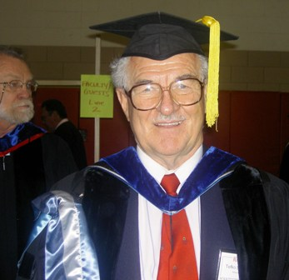 Tefko Saracevic, PhD
mailto:tefkos@rutgers.edu
http://comminfo.rutgers.edu/~tefko/

Call me Tefko. Everybody does.
As to my last name, I get these calls: “Is this Professor Sa … Sa … Sa …?” “Yes! That’s him” I answer. And let it go at that.

I am a professor. That I am indeed can be plainly seen from my picture. I was also Associate Dean from 2003 to 2006. Dressing in these ancient robes once a year is pleasure, a sign of satisfaction and accomplishment. You graduate, we graduate you. We all look a bit silly, but we all are unabashedly proud at the accomplishment. It never ceases. I retired as of July 1, 2010, but I am continuing teaching as Emeritus.

In my professional adolescence I was a searcher. At Western Reserve University, Cleveland, Ohio, where my professional growing up commenced some decades ago. A group of information retrieval (IR) pioneers built as a prototype a system for searching metallurgical literature. I got to search it for questions coming from all over the world.

My professional growth went on. I left searching for research. This branched out into, evaluation of IR systems, research on how people search for relevant information and what is relevance and how to evaluate …. but that is another story, to be glanced from my web site. This led me to digital libraries and their evolution and evaluation.

I developed the original course Digital Libraries at Rutgers and taught it first time in the Fall semester 1998. I taught it regularly since, once with Michael Lesk, who also developed the first online version. The present course is significantly different than the previous ones. As a matter of fact, it changes annually – it has to- because the changes in the arena of digital libraries are fast and accelerating.

As to digital libraries, I am also involved as a co-director in the annual conference Libraries in the Digital Age (LIDA), held in the beautiful city of Zadar, Croatia. An important part of the conference is involvement of students from all over. Consider it! Three SCI students were among attendees in 2010.

I got first into online teaching by developing in Spring 2005 the online version of Principles of Searching [17:610:530 ]. It has been taught every semester online at Rutgers and even elsewhere. This semester is my fifth venture into online teaching of Digital Libraries.

Originally, I am from Zagreb, Croatia. It is a small but beautiful country with, among others, a rugged coast, marvelous islands and old cities. My site (under Favorites) shows some of them. I loved to mountaineer and ski in Croatia. Well, after I came to the US love for mountains and skiing is still with me. Alta, Utah, is my favorite place – picture is from there (February 2010), (BTW, the crash in March 2007 when I ended on crutches afterwards is not shown). My kids (son, a journalist and daughter, a lawyer) are also infected with love for skiing, and now even my grandkids (two girls from daughter and boy and girl from son) have taken it up with gusto as well. We all meet at Alta once a year.
What else do I like? I traveled a lot, still do, and consider travel one of the greatest of human enterprises. I also read a lot. Usually about three books at the same time. A professional one that came along recently; an interesting non-fiction one from the likes of The six wives of Henry VIII or John Adams to Physics for poets, and before falling asleep a trashy spy or detective or science fiction novel. Used to like Nero Wolf stories (anybody remember him?). Of course, I am getting addicted to late Stieg Larsson’s trilogy “The girl who... .” Well, I am not sure that I should admit this, but I got from a booksale at a public library Frank McLynn’s “Napoleon. A biography.” It has become a classic and I am slowly progressing through it. What a complex man he was who turned history upside down. Next in line is a revisit to one of my old favorites from some decades ago: “I, Claudius” by Robert Graves. Also a classic. Also got it at a library book sale.
I am a lousy cook but love barbecuing - accompanied by a glass of nice wine, of course.

And I really and genuinely like teaching.

