Principles of Searching e530
DISCUSSION FOR UNIT 11
Title | Mediation and user modeling
Why? | Mediation is a process where an intermediary – a searcher – acts on behalf of a user who seeks information. User modeling means identifying all kinds of elements about a user that impact searching, - specification of information need and question, selection of search sources, types of search, and types of results provided.  As complex processes, mediation and user modeling involve a number of ethical issues. So do searches geared toward evaluative bibliometric data, as treated in the past two exercises.  We already raised ethical issues in the assignment. Now we are going to discuss them at some length. (The lecture on ethics is in unit 14)
What? | Searchers – you – should be fully cognizant about ethical issues and dilemmas involved with mediated searching, user modeling, as well as evaluative bibliometric searching. With proliferation of web searching the ethical issues became even more urgent.  There are numerous ethical guidelines to be followed. If not, searchers loose the most precious commodity they have in the eyes of users: trust.  Codes of professional ethics in librarianship, information science, and computer science are general guides for ethical decision making. They have direct implications for searching. But only very few ethical guidelines specifically addressed searching in the past. No guidelines directly address contemporary ethical issues in searching. Some quarter century ago Shiver, Hewison & Wykoff (1985) suggested guidelines for ethical behavior of online searchers:  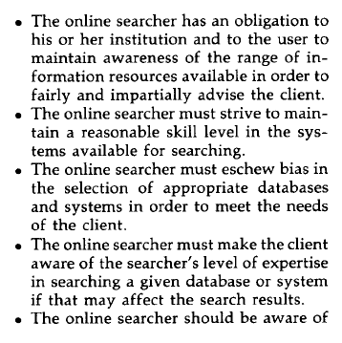  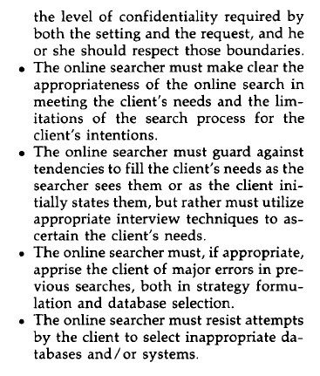  Address the questions:  - To what extend are points in these guidelines still valid today, in contemporary searching?  - Which ones should be changed/deleted/adapted to reflect contemporary situations and contexts?  - What new guidelines should be added?  - You may also wish to debate the need for such guidelines to start with.
How? | Group C should lead the discussion:  Prepare answers, questions; take a lead in responses, critiques. Challenge.  But as always discussion is not limited to the questions above. Other issues can be raised. Even a free-for-all is invited.

