Exercise01 example
Exercise 1: Example of a search
(to capture screens & edit screen shots I use a software package name Snagit from TechSmith)

Go to http://www.dialogweb.com/
- Enter your ID (I sent you) and PW: mlis0908
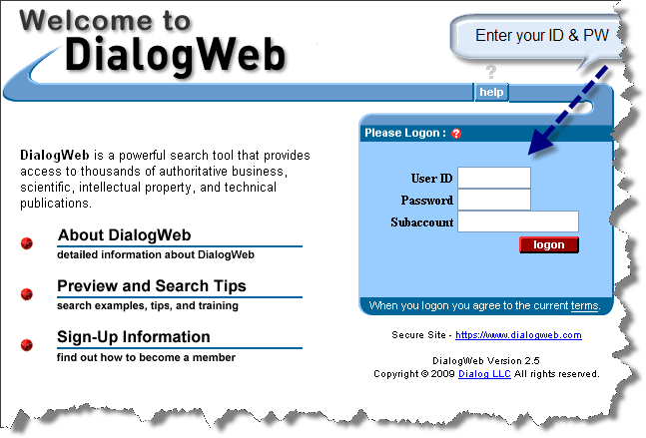
- Either search for databases or enter a command (I entered command b1, meaning I want to start database 1, ERIC – see next slide)
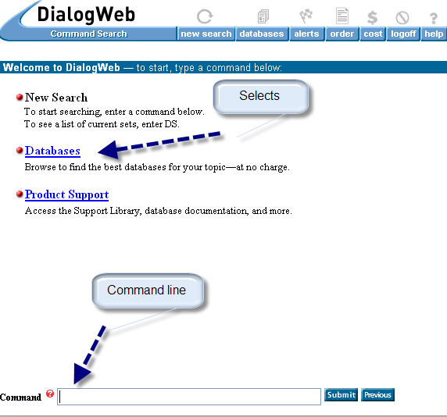

- Begin 1, (meaning database ERIC) but if I clicked Databases I could have gotten to 1 by selecting further options – experiment!
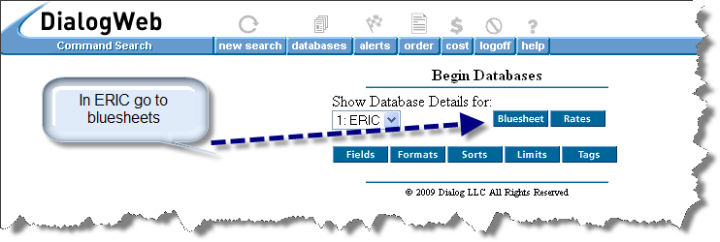

- Now I am in ERIC, but should examine its Bluesheet – gives me all information about the database, its fields, forms of outputs and more. Bluesheets are very important! Consultthem all the time! Go through this one.
[A Bluesheet for a database has a lot of stuff, some for the moment is close to goobledygook. But Bluesheets will be a very important and a constantly used source of information for you throughout your searching life of Dialog. Plus they tell you a lot how databases are structured and what fields they have and what outputs are available and how to enter them]
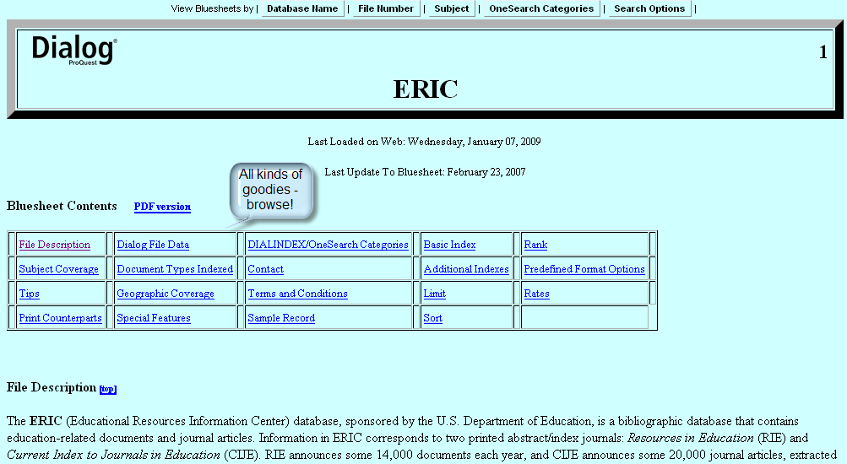

- Back to command line: I entered s (or select) library AND students (s is a command that you MUST use when entering terms you want) 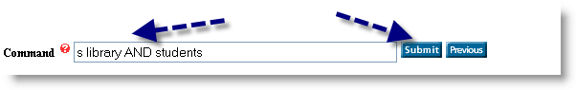
- Now I got the results. The retrieved items are in set 1 (S1). I have a choice of formats.
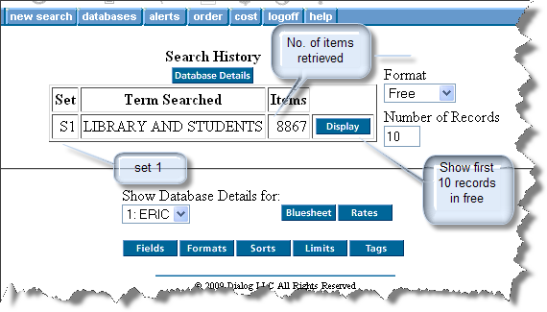

- Here are the first three items retrieved. Dialog works on LIFO principle – Last In First Out, thus these are the newest ones. I chose the third one for further examination: 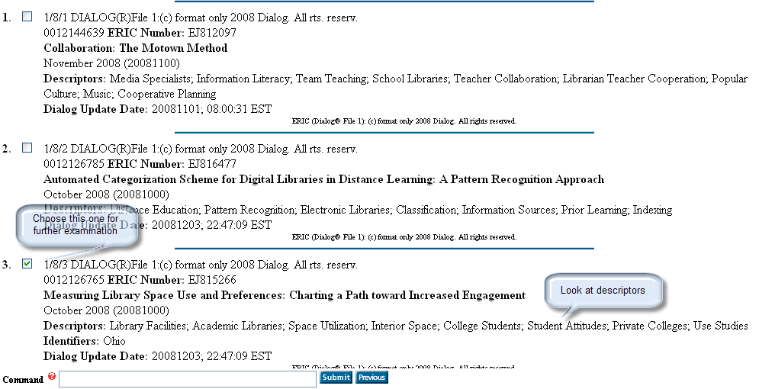

- The full record for this item – you can print it, save it, copy-paste etc ... To get the full text you have to note the journal and go to RUL (or any other source that has the journal) and get it.
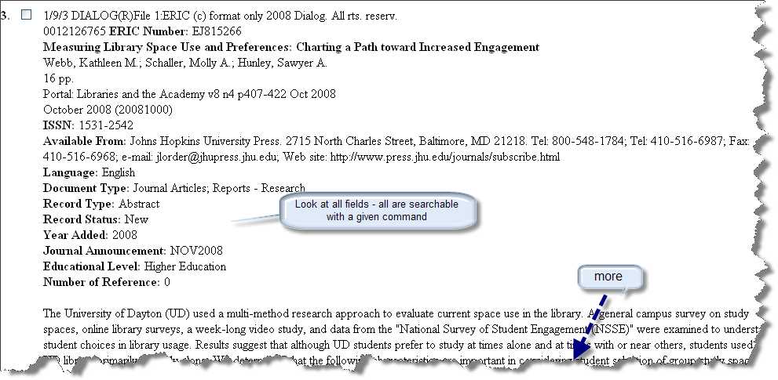

REPEAT AND YOU DID YOUR FIRST SEARCH!
Click on Costs before you logoff. Remember that you are not paying (Dialog has an educational program free for students), but if you were a regular user, this will tell you how much did it cost to do the search.

