Tefko Saracevic
How to register for Scopus on Rutgers University Scopus Trial Program
- go to http://www.scopus.com/register
- You will get this page for registration:
a. Enter the Registration ID I sent you. It is case sensitive – x is lower case. Below is an example of registration ID that I registered.
b. Enter the seven number Registration Password I sent you. Example: 1234567
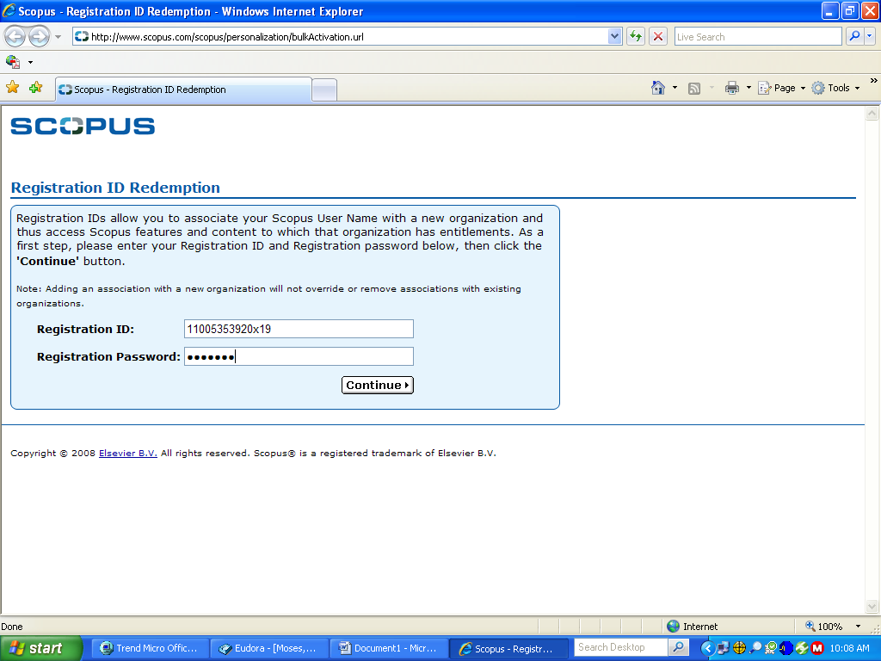

- You will get this page. Go to section that says:
“If you do not have a Scopus User Name, you may Register Now.”
(ignore the left side with user name and password)
Click on Register Now
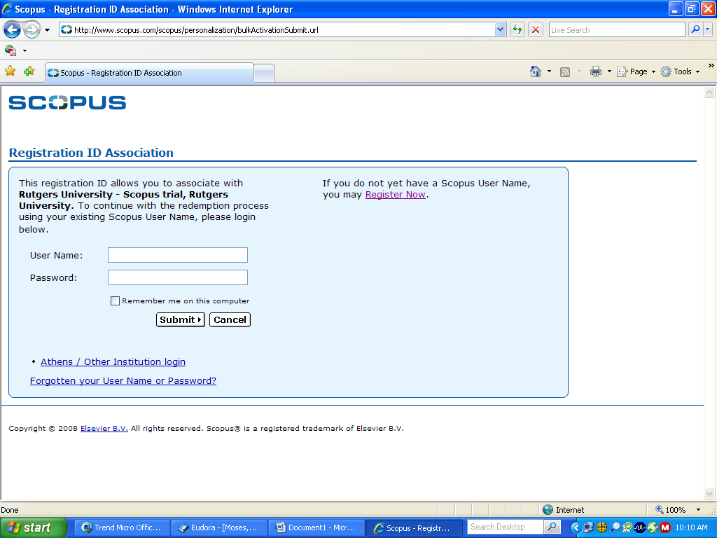

- You will get this page:
a. Enter the information as required. here is an example of information I entered. Choose a password for yourself.
b. Check that you have read the Scopus Registered User Agreement
c. I also checked Social Sciences as my Primary Field of Interest
d. Click Submit (you can enter Optional Information if you wish)
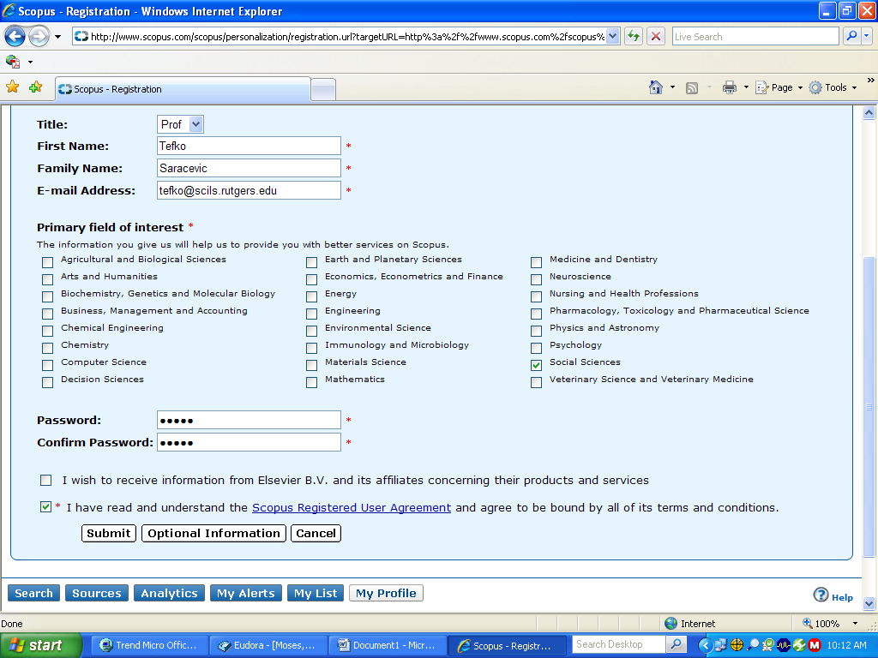

- You will get this page:
The last line is the User Name Scopus gave you. This is the User Name you will use for login, along the password you have chosen.
Click on Login
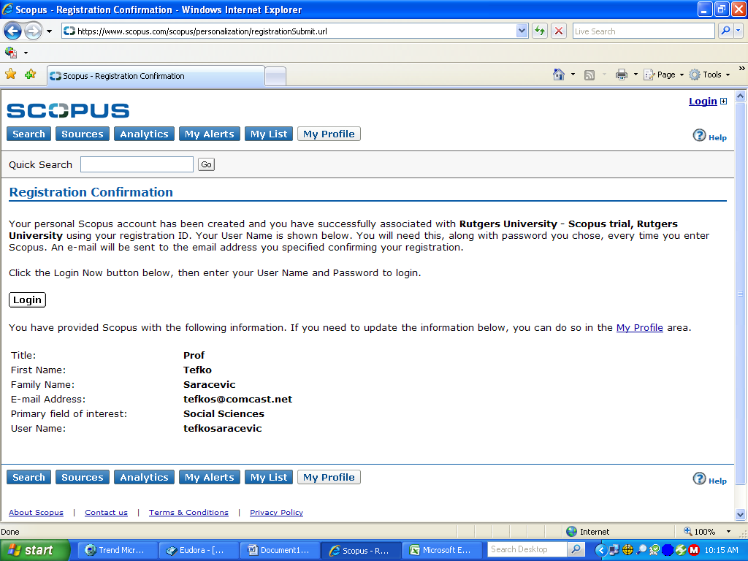

- You will get this page:
Enter your User name and Password
Click Login
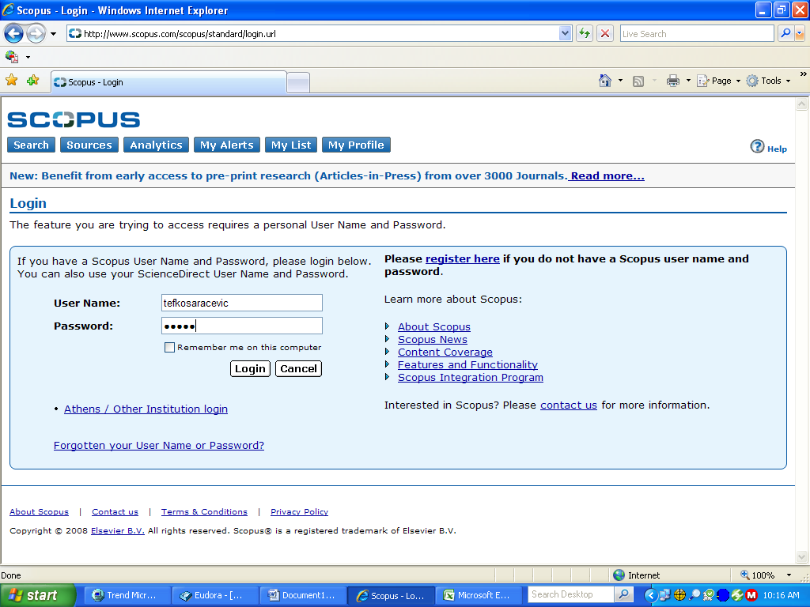

- BINGO! you are in and ready to start searching and exploring!
