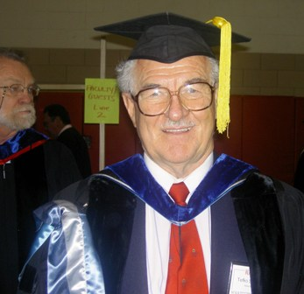 Tefko Saracevic, PhD
tefkos@rutgers.edu
http://comminfo.rutgers.edu/~tefko/

Call me Tefko. Everybody does.
As to my last name, I get these calls: “Is this Professor Sa … Sa … Sa …?” “Yes! That’s him” I answer. And let it go at that.

I am a professor. That I am indeed can be plainly seen from my picture. I was also an Associate Dean from 2003 to 2006. Dressing in these ancient robes once a year is a pleasure, a sign of satisfaction and accomplishment. You graduate, we graduate you. We all look a bit silly, but we all are unabashedly proud at the accomplishment. It never ceases.

In my professional adolescence I was a searcher. That was at Western Reserve University (now Case Western Reserve University), in Cleveland, Ohio, where my professional growing up commenced some decades ago. There, a group of information retrieval (IR) pioneers built as a prototype a system for searching metallurgical literature. It became operational. I got to search it for questions coming from all over the world.

My professional growth went on. I left searching for research. This branched out into, evaluation of IR systems, research on how people search for relevant information and what is relevance and how to evaluate …. but that is another story, to be glanced from my web site. This led me, among others, to digital libraries and their evolution and evaluation. And then back to searching.

I developed the original course Principles of Searching at Rutgers and taught it under different names since early 1990s. In 2005 I also developed with a team the online version which was taught and modified by a variety of instructors ever since. The present course is significantly different than the previous ones. As a matter of fact, it changes annually – it has to- because the changes in the arena of searching are fast and accelerating.

As to digital libraries, I am also involved as a co-director in the annual conference Libraries in the Digital Age (LIDA), held in the beautiful city of Dubrovnik, Croatia. An important part of the conference is involvement of students from all over. Consider it! Two SCILS students were among attendees in 2008.

Originally, I am from Zagreb, Croatia. Croatia is a small but beautiful country with, among others, a rugged coast, marvelous islands and old cities. My site (under Favorites) shows some of them. I loved to mountaineer and ski in Croatia. I still go mountaineering there at occasional visits. And swimming in the Adriatic Sea.

Well, after I came to the US the love for mountains and skiing is still with me. Alta, Utah, is my favorite place – picture is from there (February 2007), (BTW, the crash in March when I ended on crutches afterwards is not shown). My kids (son, a journalist and daughter, a lawyer) are also infected with love for skiing, and now even my grandkids (two girls from daughter and boy and girl from son) have taken it up with gusto as well. We all meet at Alta once a year. I am off to Alta again in February 2009 with the whole brood. I will teach the course from there.
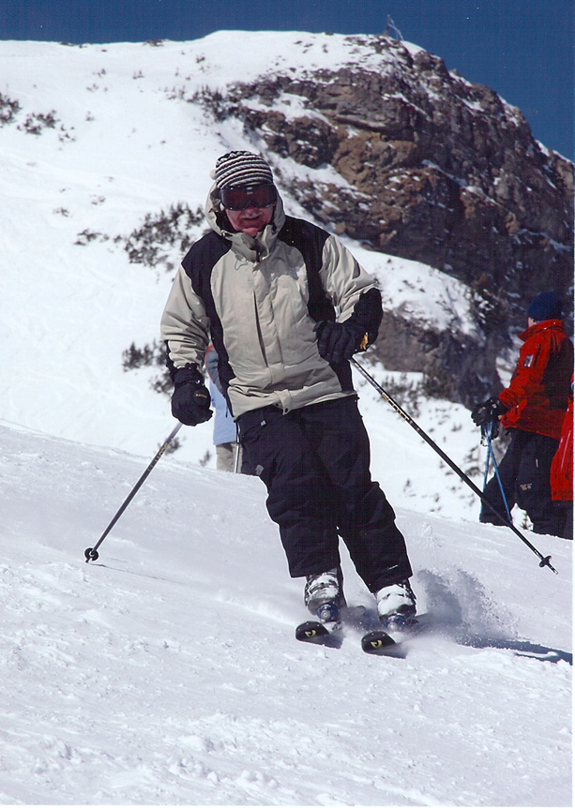
What else do I like? I traveled a lot, still do, and consider travel one of the greatest of human enterprises. I read a lot. Usually about three books at the same time. A professional one that came along recently; an interesting non-fiction one from the likes of The six wives of Henry VIII to Physics for poets, and before falling asleep a trashy spy or detective or science fiction novel. Used to like Nero Wolf stories (anybody remember him?). Well, I am not sure that I should admit this, but I got the new translation of Tolstoy’s War and Peace, and I am struggling with it – read it first time sometimes in early youth decades ago – and I am not sure why at all. It is a long, long book. And in this translation they are faithful to Tolstoy’s original and the nobles speak in French that is translated in the footnotes not in text proper, and there are pages of endnotes and thus the reading is not linear, but back and forth to footnotes and endnotes – which is annoying. Oh well, I feel noble for struggling with Tolstoy. He is a good guy.
I am a lousy cook but love barbecuing - accompanied by a glass of nice wine, of course.

And I really and genuinely like teaching.

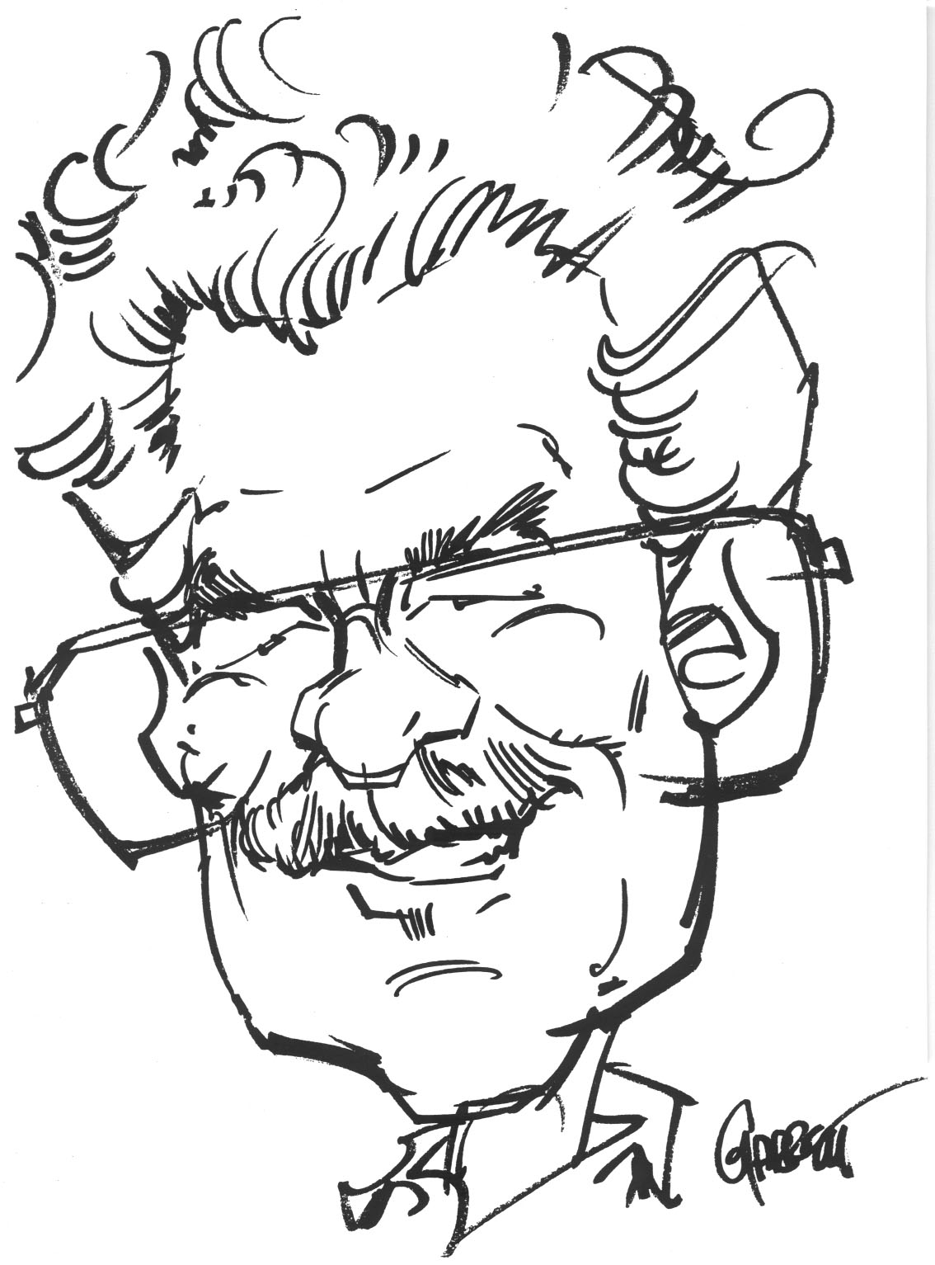

P.s. Professors are not associated with the concept of “elegant.” But here is a recent elegant picture in no way representing the usual me.

