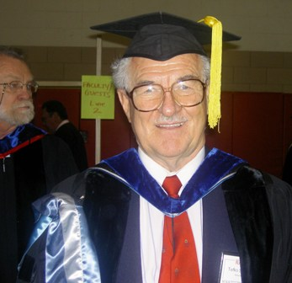 Tefko Saracevic, PhD
tefko@scils.rutgers.edu
http://www.scils.rutgers.edu/~tefko/

Call me Tefko. Everybody does.
As to my last name, I get these calls: “Is this Professor Sa … Sa … Sa …?” “Yes! That’s him” I answer. And let it go at that.

I am a professor. That I am indeed can be plainly seen from my picture. I am also an Associate Dean. That can also be seen from the picture. Namely, if you look carefully, you will see Dean Gus Friedrich in the background. Dressing in these ancient robes once a year is a pleasure, a sign of satisfaction and accomplishment. You graduate, we graduate you. We all look a bit silly, but we all are unabashedly proud at the accomplishment. It never ceases.

In my professional adolescence I was a searcher. At Western Reserve University, Cleveland, Ohio, where my professional growing up commenced some decades ago,
a group of information retrieval (IR) pioneers built as a prototype a system for searching metallurgical literature. Eventually, it became the first operational commercial computerized IR system. A few years after it got developed, I became a searcher for the system. Metallurgical scientists and engineers from all over sent in questions and I wrote programs for searching (at the time you wrote programs for that). I searched for “Growth of single crystals” or some such and waited for answers to come back after a while. Some were even relevant.

My professional growth went on. I left searching for research. This branched out into, research on how people search and what is relevance and how to evaluate and …. . But that is another story, to be glanced from my web site.

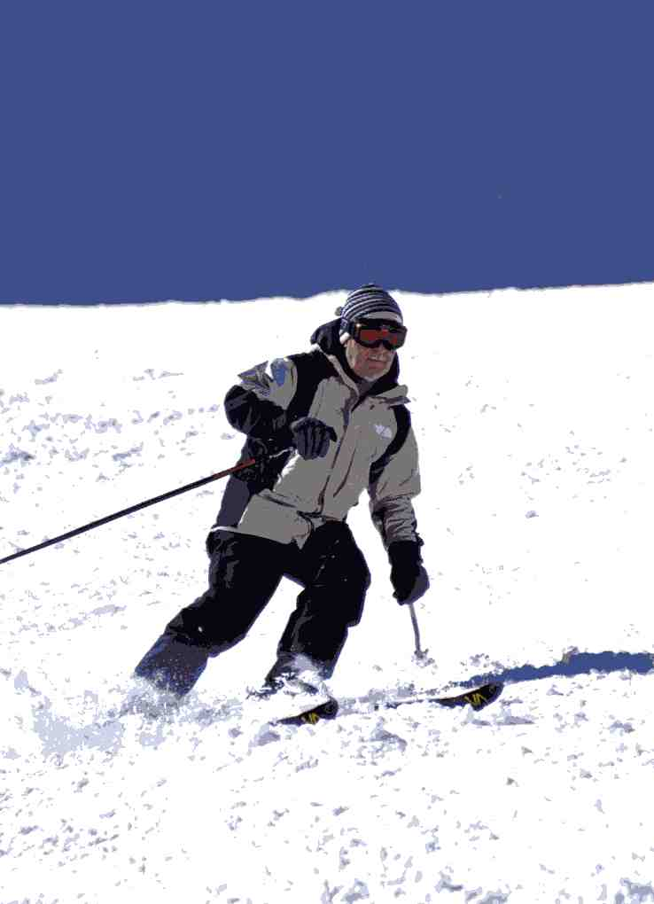
Originally, I am from Zagreb, Croatia. It is a small but beautiful country with, among others, a rugged coast, marvelous islands and old cities. My site (under Favorites) shows some of them. I loved to mountaineer and ski in Croatia. Well, after I came to the US love for mountains and skiing is still with me. Alta, Utah, is my favorite place – picture is from there (the crash afterwards is not shown). My kids (son, a journalist and daughter, a lawyer) are also infected with love for skiing, and now even my grandkids (two girls from daughter and boy and girl from son) have taken it up with gusto as well. We all meet at Alta once a year.

What else do I like? I traveled a lot, still do, and consider travel one of the greatest of human enterprises. I read a lot. Usually about three books at the same time. A professional one that came along recently; an interesting non-fiction one from the likes of “The six wives of Henry VIII” to “Physics for poets” and before falling asleep a trashy spy or detective or science fiction novel. Used to like Nero Wolf stories (anybody remember him?). I am a lousy cook but love barbecuing - accompanied by a glass of nice wine, of course.

And I really and genuinely like teaching.

