Digital Libraries -e553
Drawing that explains copyright: http://erikjheels.com/?p=803 :
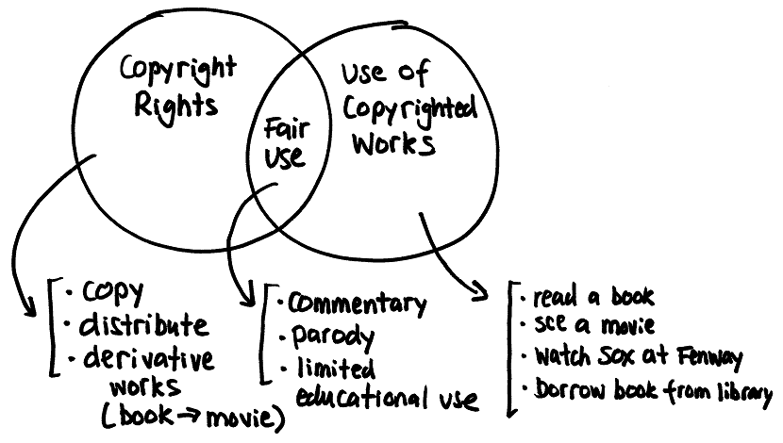
EXERCISE FOR UNIT 13
Title | Digital libraries: Legal issues
Why? | VOLUNTARY for extra credit or for you just to learn some more. There is no specific assignment or exercise for this unit – your time is directed toward completion of your term project. Thus, there are NO deliverables specific to legal issues.  However, I am encouraging you to get familiar with and learn about legal aspects of digital libraries.
What? | As an exercise you may wish to go through some of these:  - US Copyright Office – the horse’s mouth http://copyright.gov/  - ALA's Copyright Advisory Network http://www.librarycopyright.net/  “This website is a way for librarians to learn about copyright and to get help when they have copyright troubles. The purpose of this site is to encourage librarians to discuss copyright concerns.”  - ALA also has a site: Copyright (mentioned in unit description) http://www.ala.org/ala/issuesadvocacy/copyright/index.cfm  - Assoc. for Research Libraries: Know Your Copy Rights…a Web site for librarians - http://www.knowyourcopyrights.org/index.shtml  “A Web site for librarians who are developing positive educational programs for academic users of copyrighted materials in US not-for-profit institutions.”  - Creative Commons http://creativecommons.org/  A movement providing an alternative to copyright. “Creative Commons develops, supports, and stewards legal and technical  infrastructure that maximizes digital creativity, sharing, and  innovation.”
Questions? | If you looked at these:  - What is a most interesting thing (or things) you learned?  - In your opinion, how does it apply to digital libraries?  Include Goldilocks evaluation:  __This exercise was too easy  __This exercise was too hard  __This exercise was just right

